

DESIGN AND EVALUATION OF AN AGENTIC ANALYTICS FOR TECHNICAL AND NON-TECHNICAL USERS IN THE AUTOMOTIVE DEALER DECISION SUPPORT

Regina Adobea Essien
2000240011

A RESEARCH PROJECT SUBMITTED TO THE FACULTY OF COMPUTATIONAL SCIENCES AND INFORMATICS IN PARTIAL FULFILLMENT OF THE REQUIREMENT FOR THE AWARD OF THE DEGREE OF MASTER OF SCIENCE IN DATA SCIENCE AND ANALYTICS

JUNE 2026

DECLARATION
This is to declare that the research work documented in this Project Report/Thesis has been carried out by the under-mentioned student under the supervision of the under-mentioned supervisor. The student and supervisor(s) certify that the work documented in this thesis is the output of the research conducted by the students as part of their MSc thesis in partial fulfilment of the requirements for the Master of Science (MSc) degree in Data Science and Analytics
…………………………………  Regina Adobea Essien  (Student) | …………………………………  Date
…………………………………  Mr. Jeremiah Ishaya  (Co – Supervisor) | …………………………………  Date
…………………………………  Dr. Grace Oletu  (Supervisor) | …………………………………  Date

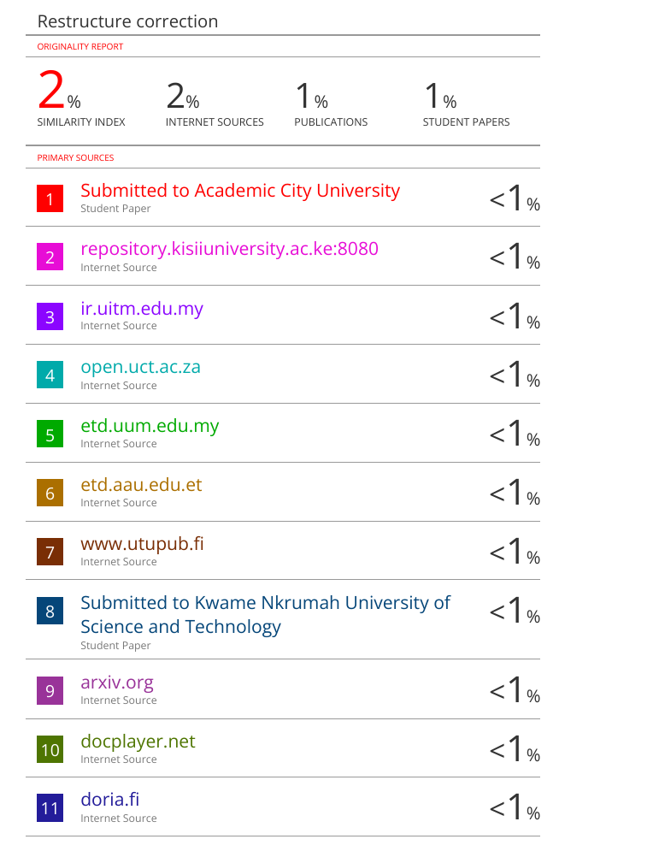
DEDICATION
I dedicate this thesis to myself for the resilience, the quiet perseverance and the strength to keep going even on the days that it felt impossible. Through moments of doubt, exhaustion and uncertainty, I chose not to give up. This journey revealed the strength and confidence within me, one that I will carry for the rest of my life. To my parents and siblings for their love, sacrifice, guidance, and unwavering support throughout my studies. This milestone is as much yours as it is mine. And to everyone who supported me along the way, thank you for being part of this journey.

ACKNOWLEDGEMENT
First and foremost, I thank God for His guidance, strength, and protection during this program. I am forever indebted to my parents for the immense support, sacrifices and encouragement.
My utmost gratitude to my supervisor, Mr Jeremiah Ishaya, for his patience, guidance, and valuable feedback throughout this research. I am also very thankful to my CTO, Mr Chetan Seth, for his mentorship and support during the development of this work.
Finally, I thank my line managers, Ms Edith Akati and Mr Mohammed Iyamu, for their leadership and support, which influenced my thinking and approach to this project.

ABSTRACT
Due to strong partnership with car dealers across multiple African countries, the commercial teams focus on key metrics such as car listings, leads, applications, and sales to determine which dealers to prioritise and which engagement actions to take. In practice, analytics workflows are mostly manual and done on several dashboards that struggle to provide a unified view of the business and to answer complex business questions. At the same time, the direct use of large language models for strategic decision support can lead to incorrect outputs and unsafe access to enterprise data. This study seeks to address these challenges by designing, implementing, and evaluating tools built with agentic AI for dealer performance analytics and reporting . The proposed system is inclusive of a user interface built with Streamlit, connected to an MCP-based database layer that only allows read-only SQL, and an LLM-driven layer that converts user requests into structured tool calls and grounded responses. Due to the data sensitivity of enterprise data, the dataset used for this study is a combination of a Kaggle listings source and synthetic data that reflects The proposed system was compared against a baseline system under the same prompts and data conditions. Across 13 evaluation prompts, the proposed system achieved 100% and the baseline 61.5% numeric accuracy on structured queries. The proposed system also achieved a higher full task completion rate of 100% compared to the baseline (53.8%), especially in the multi-task tasks. This improvement came with an efficiency trade-off and an agentic system that required more tool calls per task (mean: 2.2 and median: 2) as compared to the baseline system (mean: 1.85, median: 1). The results show that although the baseline system is efficient, the proposed agentic system provides more flexibility and improved scope adherence for complex analytics tasks.
TABLE OF CONTENT
Chapter 1 1
INTRODUCTION 1
1.1 Background to the Study 1
1.3 Research Aim 4
1.4 Research Objectives 5
1.5 Research Questions 5
1.5 Scope and Delimitation of the Study 6
1.6 Significance of the Study 6
1.7 Structure of the Dissertation 7
Chapter 2 8
LITERATURE REVIEW 8
2.1 Introduction 8
2.2 The Evolution of business intelligence to natural language analytics 8
2.3. Text-to-SQL and Enterprise Analytics 9
2.4 From Text-to-SQL to Agentic Systems 11
2.5 From pure data retrieval to automated analysis and visualisation. 13
2.6 Human-focused and real enterprise considerations in agentic analytics 15
2.7 Synthesis and Research Gap 17
Chapter 3 19
METHODOLOGY 19
3.1 Research Design and Approach 19
3.2 Data Collection and Data Sources 21
3.2.1 Synthetic relational dataset, EDA, data controls and data validation. 21
3.2.2 Synthetic Dealer, Lead, Application, and Sales Data 24
3.2.3 Database Storage in Postgres 33
3.4 System Design and Implementation Procedure 33
3.4.1 System A: Text-to-SQL Baseline 33
3.4.2 System B : Text-to-SQL with explanation 35
3.4.3 Proposed Agentic System C 36
3.4.3.1 Root Agent 38
3.4.3.2 Semantic Knowledge Graph with Neo4j 39
3.4.3.4 PostgreSQL database 39
3.4.3.5 Implementation of Custom Deterministic Tools 39
3.4.3.6. Calculation Tools 40
3.4.3.7. Visualization Tool 40
3.4.3.8 In-session Memory 40
3.4.3.9 Agent Behaviour Under Tool Failures or Runtime Issues 41
3.4.3.10 Significance of the Root Agent Design 41
3.4.3.11 Evaluation Environment 41
3.4.3.12 Prompt Set and Task Coverage 41
3.5 Ground Truth and Verification Procedure 59
3.6 Task Completion and Scope Adherence Assessment 60
3.7 Efficiency Measurement Procedure 60
3.8 Tools and Software 61
3.8.1 Development tools and libraries 61
3.10 Ethical and Responsible Data Use 64
3.11 Summary 65
Chapter 4 66
RESULTS 66
4.1 Overall Summary of Results 66
4.1.1 Results for Accuracy of Numeric Outputs (RQ1) 67
4.1.2 Results for Task Completion and Scope Adherence (RQ2) 72
4.1.2.1 Average completion score (a subset of task completion rate) 75
4.1.3 Results for Efficiency Trade-Off (RQ3) 78
4.2 Efficiency (Tool Calls or Processing Steps) 78
Chapter 5 80
DISCUSSION 80
5.1 Discussion 80
Chapter 6 82
CONCLUSION AND RECOMMENDATION 82
6.1 Conclusion 82
6.2 Limitations 83
6.3 Future Work 84
References 86

LIST OF TABLES
Table 3-1: Summary of the baseline and proposed system designs used in the evaluation. 22
Table 3-2: Showing a summary of Postgres tables used in the Dealer Copilot dataset (row and column counts) 26
Table 3-3: Account Manager dataset showing fields with data types 27
Table 3-4: Application dataset showing fields with data types 27
Table 3-5: Dealer activity metrics table 28
Table 3-6: Dealers Scores table 29
Table 3-7: Dealers table 30
Table 3-8: Leads Table 31
Table 3-9: Listings Table 32
Table 3-10: Sales Table 34
Table 3-11: List of evaluation prompts used in the experiments 58
Table 4-1: Evaluation results across 13 prompts 72

LIST OF FIGURES
Figure 3-1: Runtime flow of the Dealer AI Copilot 49
Figure 3-2: Custom tools in ADK frameworks 54
Figure 3-3: System architecture of the Dealer Copilot and Baseline System 58
Figure 4-1: Baseline and proposed system outputs for a total applications query in Ghana 74
Figure 4-2: Screenshot from baseline model system output for “How many dealers are in Ghana” 75
Figure 4-3: Screenshot from proposed system output for “How many dealers are in Ghana” 76
Figure 4-4: Trend comparison prompt executed on the proposed agentic Dealer Copilot 76
Figure 4-5: Trend comparison prompt executed on the baseline system 77
Figure 4-6: Baseline outputs for the prompt “Generate a chart comparing the monthly sales trend and monthly applications trend 79
Figure 4-7: Proposed System outputs for the prompt “Generate a chart comparing the monthly sales trend and monthly applications trend 80

LIST OF ABBREVIATION
CLI | Command-Line Interface
ADK | Agent Development Kit
MCP | Model Context Protocol
SQL | Structured Query Language
UI | User Interface
ReAct | Reasoning and Acting
MRKL | Modular Reasoning, Knowledge, and Language
AI | Artificial Intelligence
LLM | Large Language Model

INTRODUCTION

1.1 Background to the Study
In modern organisations, taking operational and strategic decisions heavily depends on timely access to not just any data but accurate and well-structured data. Every department and team uses data to monitor performance, identify challenges, allocate resources, assign tasks, and respond quickly to changing market conditions. However, access to data and quick insights depend on people with technical skills such as SQL, data analysis, and business intelligence tools like POWER BI, Tableau, etc. As a result, decision-makers may have access to large volumes of data but still struggle to get clear, timely, actionable insights.
Text-to-SQL came in to reduce a significant part of this barrier by helping users to query databases in natural language or plain English instead of just writing SQL queries themselves. However, simply making query generation easier does not actually eliminate the technical expertise required to understand the results. Users still need to analyze the returned tables, metrics, spot trends, compare tables, and most importantly, translate them into actionable insights. In the end, non-technical users will still remain heavily reliant on analysts even with Text-to-SQL.
More recently, there has been growing interest in agentic AI systems, which are an alternative solution to help interpret business questions. They are designed not only to respond to user prompts but also to interpret intent, plan actions, retrieve information, and use tools to complete tasks. These features definitely enable multi-step analysis, generate charts, and communicate findings in natural language. Agentic analytics offers a potential step towards self-service analytics.
Agentic systems bridge the gap between users, especially non-technical ones, and data. When the agentic systems are safely connected to the right database, they can support prompting specific to the company in an accurate, safe, and controlled manner.
In the automotive finance and digital marketplace sectors, the above problem is highly evident and contextual. The automotive digital platforms are meant to connect car sellers to buyers through car listings, trade-ins, car financing, and after-sales maintenance. Because of platforms like that, monitoring car sellers or car dealers' performance is central to the growth of both online and offline marketplaces, as well as enabling customer satisfaction
Constant engagement with these car dealers depends on monitoring of K.P.Is or metrics such as inventory, customer interest, and financing activity, both for business expansion and customer satisfaction, as well as their sales. However, these metrics are often monitored through multiple dashboards and sheets, but never through a unified view, making it difficult to understand and address the challenges in such a sector
There are a lot of studies that have highlighted the fact that the automotive ecosystem(dealerships) experiences inconsistent performance because of the lack of detailed analysis and manual coordination (Almohri et al., 2019).
In this study, an automobile financing company is used as a case study. There are few automobile financing companies. Most of them run a digital automotive financing marketplace that connects car dealers, buyers, and financing partners across multiple African markets like Ghana, Nigeria, Uganda, Kenya, CIV, and Senegal. Managing dealer performance at this scale requires timely, consistent, and data-driven support across different countries. Within their dealer operations, there are four key metrics that are essential for decision-making: listings, leads, loan applications, and sales. Listings show vehicles published on the marketplace and are closely tied to inventory visibility. Leads represent potential buyers who are generated from those listings. Loan applications record financing requests made through the platform, and finally, sales indicate successful transactions. Together, these metrics provide a practical operational basis for dealer monitoring and engagement, evaluating dealer performance. Despite the availability of these metrics, the challenge lies in accessing and analyzing them in a unified, timely and user-friendly manner. In database analytics specifically, a simple LLM-based approach is Text-to-SQL where a language model converts a user’s natural language question into an SQL query, executed on a relational database(Yu et al., 2019), (Rajkumar et al., 2022). Text-to-SQL is a well-established research area that focuses on translating natural language questions into SQL queries that can be executed over a relational database. More recent studies have shown that Large Language models can support the generation of SQL through prompting.
Even though this approach improves accessibility, it does not necessarily provide multi-step and dynamic tool selection and planning or visualization support. Large language models can improve natural language interaction but using them directly for operational reporting may produce generic outputs if they are not connected to reliable data sources. Therefore, there is a need for a system that combines the flexibility of natural language interactions with the reliability of controlled database access.
Tool-grounded agentic AI offers a promising approach to this challenge. In this approach, the language model is responsible for interpreting user intent and planning the task, while deterministic custom-built tools retrieve data, compute scores and generate outputs from structured sources. This separation between reasoning and execution helps reduce hallucination, errors, improves traceability and support safer operational analytics. However, existing works on agentic AI often focus on general capability demonstrations rather than evaluating its usefulness in domain-specific operational reporting against a non-agent baseline.
This research seeks to investigate whether a tool-grounded agentic analytics system can improve efficiency, accessibility, and comprehension for non-technical users while maintaining robustness, analytical accuracy, and traceability. In an automotive -financing context, the proposed system, Dealer AI Copilot, will be compared to Text-to-SQL baselines across several analytical tasks and users with different levels of technical expertise.

1.2 Problem Statement
In the dealer operation heavily depend on key metrics, which are listings, leads, applications, and sales. However, these metrics are never presented in a unified view. The current situation is that, to analyze dealer performance, employees will have to move between several dashboards and data sources and sometimes require some technical skills, such as SQL queries and Excel formulas, to make meaning out of the data. The problem is not the absence of data, but rather that data is scattered all over and thereby requires manual analysis for decision-making and reporting. This slows down operational decision-making and reporting and takes even longer for non-technical people.

1.3 Research Aim
This study seeks to design and evaluate an agentic AI decision-support system for technical and non-technical users. This system provides a unified view of all the dealer metrics (listings, leads, applications, and sales) to help employees make meaningful and justifiable decisions. The aim of this research is also to explore if the proposed agentic system can ease dealer analytics and reporting in the automotive-financing industry and also to compare the proposed system to an LLM-to-SQL baseline.

1.4 Research Objectives
1. To provide a unified view of dealer metrics such as listings, leads, applications, and sales in a consistent dealer-level overview.
2. To design and implement an agentic AI system that can understand user requests, plan the necessary steps, and retrieve dealer operations data from a database.
3. To implement data-grounded reasoning through retrieval and scoring with traceable explanations.
4. To establish an appropriate non-agent baseline and compare it to the proposed agentic approach under the same data conditions.
5. To design a frontend user interface /chatbot for both the baseline system and the proposed system.

1.5 Research Questions
The main research question is: does a tool-grounded agentic analytic system actually reduce the technical expertise required to access actionable insights from data compared to -Text-to-SQL systems, and under what conditions? To address all the challenges outlined in the problem statement, the thesis aims to find answers to the following research questions:
RQ1: To what extent does the proposed tool-grounded agentic Dealer AI Copilot produce accurate numeric outputs, such as counts, totals, rankings, comparisons, and time-series values, compared to a baseline rule-based system under the same data conditions?
RQ2: How can dealer analytics and reporting be completely and effectively done in the proposed agentic system, also within the specified scope (such as country, metric, date range, and time resolution) compared to a baseline rule-based system?
RQ3: What are the efficiency trade-offs that arise when using the proposed agentic system instead of the non-agent LLM-based Text-to-SQL baseline for dealer analytics and reporting tasks?

1.5 Scope and Delimitation of the Study
This study focuses on the design and evaluation of an agentic AI system for dealer engagement and performance monitoring. It does not include full production deployment or live integration into enterprise systems, such as underwriting decisions, credit risk modelling, or the complete end-to-end customer journey. Also, because of data confidentiality restrictions and data privacy, the evaluation uses a public and synthetic dataset instead of actual data. The study uses only one agent using the Google ADK framework, complemented by custom tools, a structured database layer (PostgreSQL), an MCP-based tool interface, and an LLM (Gemini 2.5 Flash) executed through the Google ADK runtime.

1.6 Significance of the Study
Academically, this research delivers hard empirical data contrasting autonomous agent workflows against traditional, non-agent language model setups inside a live business management environment. It adds practical details on how tools are used effectively and how structured retrieval improves grounded reasoning and reliability. In practice, the work offers a prototype design for dealer operations and commercial teams, demonstrating how the key metrics can be transformed and prioritized to drive engagement and performance across multiple countries. It also proposes a reproducible evaluation approach, all while maintaining confidentiality, and allows for robust testing under realistic operational conditions.

1.7 Structure of the Dissertation
The first chapter introduces the study by providing the background to the study, problem statement, research aim, objectives, research questions, scope, and significance of the study. Chapter Two reviews relevant literature on agentic AI, tool usage, and decision support in operational settings. Chapter Three outlines the research design, data collection methods, system implementation, evaluation framework. Chapter Four presents the results and analyses of the systems’ output. Chapter Five discusses findings and finally, Chapter Six , implications, limitations, and directions for future work.

LITERATURE REVIEW

2.1 Introduction
This chapter reviews how conventional business intelligence and analytical reporting have progressed over time from the normal database query via natural language and Text-to-SQL to agentic analytical systems that can retrieve and provide their own data, generate charts, and reason on their own.
In the past, business intelligence often required technical expertise; then natural language came in to help non-technical users to ask questions in plain language. After that, Text-to-SQL came in to retrieve these prompts or questions from the database

2.2 The Evolution of business intelligence to natural language analytics
Traditional business intelligence systems were only for those with technical expertise. It mostly required knowing how to write SQL queries, Excel functions, and prepare dashboards, and understanding how to work with tables and other data, which created a huge barrier between people and the data. In the quest to decentralize data access and break the barrier, came natural language analytics. With natural language analytics, non-technical users could now ask questions or get insights by asking them in plain language. Instead of writing SQL queries. These two ideas, Text-to-SQL and NL2SQL, were used to translate natural language prompts into SQL queries. Text-to-SQL didn’t start with language models like ChatGPT; it began with an earlier rule-based approach .The queries are then executed against the database storing the data, and results are provided(Liu et al., 2026a), (Liu et al., 2026b). (Zhu et al., 2024) Explains how Text-to-SQL has evolved with the gradual development in language models. The paper surveys a group of several modern LLM approaches concerning areas such as prompt engineering and fine-tuning, etc. For instance, NL2SQL has modern features like schema linkage, evaluation, database understanding, and error analysis. However, depending only on natural language access to databases via SQL is not sufficient and does not always support actual business analysis. (Lian et al., 2024) helps provide a distinction between Text-to-SQL and his paper, where he talks about natural language to business intelligence. The distinction is that, unlike Text-to-SQL, using business intelligence introduces challenges such as ambiguous data and columns, large data and schema, and complex business semantics. The study helps us realize that business intelligence goes beyond simply converting natural language into SQL. The ChatBI architecture is therefore introduced as a solution. In the architecture, the preferred data view is chosen before the SQL queries are generated.
Amidst all the challenges with Text-to-SQL, recent papers have examined how it can still operate for analytics. The next theme provides more context to that.

2.3. Text-to-SQL and Enterprise Analytics
As Text-to-SQL systems became capable of operating in actual analytical environments, researchers began examining them under more realistic enterprise conditions instead of only on relatively academic and unrealistic benchmarks. An important architecture suitable for analytics was the BIRD benchmark (Li et al., n.d.). Unlike earlier papers that focused mainly on database schemas and relatively small databases, this architecture included about 12,751 Text-to-SQL pairs across 95 databases. The study proved that working with larger and more complex databases introduces additional challenges such as noisy data, the need for external knowledge, and SQL efficiency. The research also showed a huge difference between model and human performance, showing that more robust LLMs still find it difficult to match human accuracy when working with complex database environments. This proves that improving the Text-to-SQL model is not sufficient; the system should also draw a relationship between the data involved and have a good contextual understanding.
The gap between unrealistic Text-to-SQL performance and real business analytics is defined properly in (Lei et al., 2025) . This paper introduces 632 business and real Text-to-SQL workflow tasks based on real data. These tasks involved databases with more than 1,000 columns, multiple SQL dialects such as BigQuery and Snowflake, documents from external sources, and SQL queries. The study proved that models that performed strongly on earlier Text-to-SQL benchmarks experienced a significant drop in performance. For example, the strongest code-agent configuration solved about 21.3% of the Spider 2.0 tasks, compared with much higher performance on earlier benchmarks. This demonstrates that enterprise or business analytics is considerably more complex than generating a single SQL statement from a natural-language question, and performance on a simple Text-to-SQL does not guarantee that it will perform equally well in real business or enterprise environment
Recent research has therefore begun to place a greater emphasis on the need of semantic grounding. In an enterprise and business environment, users or employees usually think in terms of business concepts, definitions, metrics such as sales, their customers, conversion, or performance rather than mere tables and columns.An instance is shown through the LangChain Iceberg Toolkit. This paper allows querying data lakes through natural language while using a semantic layer to draw more context and grounded business decisions. Instead of simply allowing the LLM to freely generate any SQL, the system selects predefined analytical tools, executes the queries, and validates with the business definitions in a controlled manner. The evaluation reported higher accuracy than a Text-to-SQL model, which is only supported with schemas and tables as a baseline on the same set of queries. This shows the potential value of explicitly and accurately representing business definitions rather than relying only on the model to freely interpret the database schema.
These studies show that Text-to-SQL goes beyond the challenges of not being able to provide accurate queries, but in a real analytical environment, must also deal with very large schemas, business-specific metrics and terms, data values, security constraints, semantic definitions, and complex analytical workflows. This has encouraged researchers to move away from treating the LLM as a one-and-only-step solution and toward systems that can perform several coordinated actions, including planning, retrieving context, executing queries, checking results, and correcting errors. The next theme therefore examines the shift from conventional Text-to-SQL generation toward agentic query execution.

2.4 From Text-to-SQL to Agentic Systems
As researchers realised, the capabilities of Text-to-SQL systems, the quest from moving beyond a simple and, single SQL execution or generation to more complex scenarios. Complex prompts or questions require multiple schema inspections, correcting errors after so many tries. This frustration led to the exploration of agentic AI for Text-to-SQL. Agentic analytics also has a language model, but this time the system does not only rely on that to generate queries or results; part involves a whole orchestration. It involves planning, inspections of the schema, generation of the SQL queries, execution and validation, and finally results. (Wang et al., n.d.) mentions this type of framework in his paper. It has been built to support large databases, complex enterprises, and real-world questions. It is a multi-agent architecture where there is a central agent and other supporting ones to help correct the SQL queries. One advantage of this framework is that it treats the entire process as a collaboration, unlike a single Text-to-SQL.
A similar framework named QCMA-SQL is proposed by Shao et al. (2025). This framework classifies the difficulty of the questions and then routes them to the appropriate agents based on the level of difficulty, instead of treating every question in the same way, the system. It also includes selection of schema, syntax validation, and execution optimization. Optimisation in the sense that not all analytical questions require the same amount of reasoning. For instance, simple questions may be solved directly, while more difficult questions may require additional processing and validation. The author proves that the execution accuracy of 87.4% on Spider and found that question classification contributed to improved performance.
Other researchers have actually focused on validation and verification. In papers such as (Xia et al., 2025) came up with solutions like the R cube, i.e., review, rebuttal, and revisions. This is how it works: it does not always trust the first SQL execution; multiple agents cross-check the proposed query, try to challenge it, and revise it before the final results come out. (Xia et al., 2025) report a stronger performance than the single-model and multi-agent baselines on BIRD and on Spider. Another paper that uses the self-correction method is (Piao et al., n.d.) ‘s Lite-SQL. This method combines retrieving schemas and execution but self-correctness. In other words, the system retrieves all the important schema and used the feedback gathered from database execution to correct the queries. This method achieved a 72.10% accuracy in terms of execution on BIRD. This method also proves that database execution and retrieval combined with self-correctness do not depend or require large and complex architectures.
Another paper (Tian & Zhang, n.d.) also proposes another method know as PV-SQL. This framework also uses similar processes like the Lite SQL. The architecture is broken into two parts which is the Probe and Verify. The first part inspects the database queries while they are being executed. It checks the actual values, columns, and if there are any semantic relationships. The other part then checks if the required information per the user’s request or prompt is available. On BIRD, the evaluation of this framework showed great improvement in the accuracy of the execution as compared to the baseline reported.
From the studies above, we have seen a great evolution when it comes to the Text-to-SQL framework. This tells us that researchers believe that database query and execution is an iterative and analytical process instead of seeing it as a simple task.

2.5 From pure data retrieval to automated analysis and visualisation.
From the previous papers, we see how Text-to-SQL has evolved from just a simple database query to more planning and iterative steps to validate and self-correct. However, in real business or enterprise analytical environments, users may need more than accurate queries; they will need deeper insights, charts, trends, patterns, etc. The need for deep analytics and actionable insight has led to LLM-based systems that try to automate a greater part of the analytical systems.
One of the papers that attempts this is (Zhang et al., 2025). This is how the reported framework is: it starts by retrieving data just like similar frameworks, processes the data, and creates a chart in line with the user’s request. It does not rely on the LLM to calculate but uses code and predefined functions and tools to interact with the data. The author argues that this framework reduces errors significantly while improving efficiency. For instance, for a prompt, “show me the monthly sales trend and generate a chart, a simple Text-to-SQL will only generate figures, but this framework will retrieve the figures, process the data, and generate a visualization to support the answer. But one downside to this framework is reliability, because the LLM will always have to generate code to support the process and can potentially hallucinate. Another similar framework is (P. Ma et al., n.d.)’s Insight Pilot. The author aimed to reduce technical expertise while exploring and analyzing data. It does not wait for users to decide their own next analytical step; it uses the embedded LLM and an engine to generate a predefined analysis. The system performs EDA on its own by identifying certain patterns and trends as well as giving summaries based on what has been identified. In this research, the author emphasises how it is for non-technical users to achieve that thoroughly. Other researchers have extended this idea to more agents that are made for more general data analysis. In the Infi-Agent DABench paper, the author evaluates whether LLM agents can complete analysis tasks autonomously from beginning to end. In the paper, the benchmark contains 603 data-analysis tasks and requires the agents to interact instead of just producing a textual answer. This research is relevant because the evaluation focuses on whether the agent is capable of completing an analytical task using tools rather than focusing on its capabilities of generating code or SQL queries. (Hu et al., 2024)
Agentic visualization is even clearer in nvAgent. Ouyang et al. (2025). In this paper, the author proposes a more collaborative workflow which involves three agent, that is a processor agent, composer agent, and validator agent. These agents are responsible for preparing the database context; the second is responsible for planning the visualization, and the third agent is responsible for verifying the generated output. VisEval was used to evaluate the system, which showed improvements compared to earlier approaches. The system was evaluated using VisEval and showed improvements over earlier approaches for both single-table and multi-table visualization tasks. This framework is relevant because it serves as a connection between all the earlier frameworks discussed, which are planning, tool use, specialization, and validation, with the generation of analytical visualizations
Even though these systems have shown significant improvement in terms of analytical capabilities and robust technical performance, it still does not prove they are actually useful in practice, especially in real-world analytical environments.
The next thing on our minds should be that as these analytical systems become more autonomous, do user understanding, trust, verification, technical expertise, workload, latency, and cost become increasingly factored in or considered whilst building? The next theme therefore brings these concerns to light and evaluates the human-centred and real enterprise challenges and considerations surrounding agentic analytics.

2.6 Human-focused and real enterprise considerations in agentic analytics

From earlier papers, we have realised how analytical systems have evolved and become more autonomous. While this is a positive thing, examining its technical capabilities alone is not enough. For instance, a system can effectively calculate, provide correct analysis, and generate charts, but the important thing is that users should be able to understand and trust these systems; after all, the systems are meant for them. Aren’t they? This focus is what has led to human-centered evaluations and examination of these LLM-based analytical systems. (Xie et al., 2024) ‘s WaitGPT looks at how users monitor and keep close watch while interacting with LLM-based agents for analysis. Unlike some of the previous frameworks that generate code and pilot the answers and insights, WaitGPT visualizes or gives detailed and analytical steps being carried out. The study found that this approach helped users identify errors and increased user trust and confidence in the analysis. The study proves that transparency and verification become significantly relevant when the system is meant to handle several analytical operations for users.
(Improving Steering and Verification in AI-Assisted Data Analysis with Interactive Task Decomposition - Microsoft Research, n.d.) is a literature review that focuses on how users can better verify the results of data analysis. The author notes that a conversational chatbot for data analysis is actually more harm than good, as it poses as a black box. For instance, if the user puts in a prompt, the conversational AI just produces the results but might not provide the steps it took to arrive at that decision or result, which is a problem because AI can make mistakes. In this paper, he therefore breaks the tasks into chunks so users can verify. The chunks per task can include choosing the metrics involved, applying a filter, calculating, generating a chart, etc depending on the user's prompt. One of the things worth noting in this paper is that users felt more in control and could easily identify the mistakes and fix if need be.
The evaluation of analytic systems has evolved over the years. In evaluating such systems, the question usually asked were if the system produced the correct answer, ignoring the whole system. (Sahu et al., n.d.) argues that that way of evaluating was too limiting, especially for agents for business analytics. This literature does a more detailed evaluation of the system. For instance, past researchers will use only tasks as the form of evaluation, but this paper will not only look at the tasks but focus on things like whether the agent can identify relevant business questions, do data analysis, and explain the results provided; in other words, the agent should be able to identify what's worth investigating, which is the very essence of developing such systems.
(C. Ma et al., n.d.) Also evaluates agentic analytic systems similarly but introduced a progress-rate measure. This measure looks at how far the agent gets through its tasks and what exactly happened midway through its steps. The literature argues that evaluation should consider not only results but also the processes involved in achieving them, which informs the architecture of system C.
The above literature proves that agentic analytics evaluation should go beyond task success rate or accuracy and also consider these as well: 1. How easy it is for users to comprehend and verify the results achieved(transparency), how much effort it takes users even to interpret the results, and how efficient, safe, and robust the systems are. Human-centered and focused analytics is the gateway to bridging the gap of the reliance on technical expertise in accessing data

2.7 Synthesis and Research Gap
So far, the literature review has outlined some frameworks such as LLMs that can generate SQL queries, and agents that can reason, act, and think autonomously. We see this in papers like InfiAgent, Data Copilot, and Insight Bench, but the gap here is that there is limited evidence that compares both Text-to-SQL and agents for analytics and examines their importance to technical and non-technical users. Recent papers have examined analytical systems end-to-end and focus on the agents' capabilities but never evaluate or explain whether these solutions actually help bridge the non-technical user gap. Another gap worth noting is how complex real enterprise data can pose a major threat while building analytical systems, and we see that in one of the studies in the literature, Spider 2.0, which shows how the models that performed well on the earlier Text-to-SQL later dropped drastically when applied to real enterprise data. The data was large and thus involved large schemas and complex operations. Another gap I would like to mention is that papers like WaitGPT required its users to thoroughly understand the steps performed by the agents, which does not favour non-technical users.
This study seeks to address these gaps by comparing three analytical systems across the same business analytical tasks and, most importantly, a human-focused (technical and non-technical users) evaluation method. This study not only focuses on analytical accuracy and a robust system but also if agentic analytics seeks to bridge the expertise gap while accessing actionable insights and data.

METHODOLOGY

3.1 Research Design and Approach
This chapter outlines an applied AI system, with a controlled experimental evaluation and a human-centered user study. It focuses on the evaluation and experimentation on whether a detailed natural language architecture helps reduce barriers for non-technical users whilst obtaining actionable insights from data. The design compares three systems for dealer analytics and reporting in a dealer operations setting. All three systems share the same database, schema, and analytical tasks. This is to avoid the deliberate attempt to assume that the proposed agentic analytics system will outperform the other systems, making it fair. This is also another reason for introducing system B. System B acts as a control because a Text-to-SQL + explanation might be beneficial as compared to an agent. In other words, System B helps us decide whether non-technical users genuinely prefer System C mainly because it is agentic or because it comes with an explanation in plain English. For instance, if we realise from the experimentation that System A(Text-to-SQL) is less effective than System B(Text-to-SQL + explanation) and System B is equal to System C (agentic analytics), then the finding will be that natural language is more beneficial to non-technical users and agentic analytics may not be necessary for analytics. However, if System A is less effective than System B and System B is less effective than System C, then we can conclude that agentic analytics add more value beyond explanation in natural language.
The proposed system (System C) uses an agentic architecture built with the Google ADK framework. Only one agent (root agent) is built and connected to a custom-built tool via MCP and a structured PostgreSQL data layer. In this setup, user questions are interpreted by the root agent by extracting certain words in a prompt and are turned into tool calls that fetch dealer activity metrics (such as listings, leads, applications, and sales), calculate dealer scores, and produce charts when needed. The system is built so that its outputs are based on only retrieved results and deterministic calculations, not on open-ended language generation.
The baseline system (Systems A and B) is also built as a non-agent LLM-based Text-to-SQL system. It uses a language model that converts English (natural language) into a single SQL query, which is executed on the same PostgreSQL database. However, the baseline does not use agentic planning, tool selection, or multi-step flow. The comparison between the baselines and the proposed system directly addresses this main research question and other questions as well. The main research question is: Does agentic analytics (System C) reduce the technical expertise barrier needed for analytics? The other questions are: RQ1 (system differences in correctness or accuracy), RQ2 (what additional benefits do the natural language and agentic architecture provide compared to Text-to-SQL), and RQ3 (to what extent do analytics systems affect the performance gap between non-technical and technical users when retrieving actionable insights). The table below is a summary of the baseline and proposed system designs used in the evaluation.

Table 3-1: Summary of the baseline and proposed system designs used in the evaluation.
System | Architecture and Execution flow | What role does it play in this experiment?
System A: Text-to-SQL | i. A natural language question; a model that helps with SQL generation  A PostgreSQL query, then a table or results | Main baseline.  No explanation or visualisation
System B (Text-to-SQL + explanation) | Same as system A, but this time it comes with a grounded explanation of results | It tests if natural language helps with closing technical user gaps
System C (agentic analytics) | Root agent built with Google ADK framework, connected to customized tools through MCP(Neo4j), knowledge graph, PostgreSQL | It tests whether the agentic architecture (semantic layer, tools, etc.) is beneficial or adds value to close the technical user gap

The structure uses Gemini 3.5 Flash-lite with medium thinking effort.

3.2 Data Collection and Data Sources

3.2.1 Synthetic relational dataset, EDA, data controls and data validation.
This section outlines the data sources used for this research. Due to privacy and confidentiality restrictions, dealer operations data was not accessible for this study. Therefore, a synthetic relational operational dataset was generated specifically for this experiment. The synthetic data represent key dealer activity metrics to reflect those of operational analytics. The dataset spans across Ghana, Nigeria, Kenya, and Uganda. The data include dealers, leads, applications, and sales, which are the key things the dealer operations department looks at. The dataset was generated on September 12, 2026, at 16:17 GMT with a fixed random seed of 42 and IDs to ensure reproducibility and relational structure in experimentation. The time period of the data runs from 1st January 2024 to 31st December 2025, with January 2026 as a buffer. Seasons, time trends, dealer diversity, and random noise were all introduced into the data to help with benchmarking. Most importantly, hidden generated truth or golden answers were set aside to prevent experimental leakage. They are never exposed to the evaluated systems. The purpose of the EDA was not only because the dataset is synthetic but also because the data was used as a source of experimental validation. The first thing it checks is whether the generated dealers have sufficient variation, have a reasonable business funnel, the ability to change over time, and behave differently. In the first stage of the data exploration, the overall funnel structure was examined. The four tables are not independent but have a relational structure. For instance, the applications are a result of the existing leads and sales from the approved applications. The lead-to-application conversion rate is around 29.63%, application to approval rate conversion is 64.62%, and the application-to-sale rate is 55.57%, whilst the lead-to-sale conversion rate is 10.64%. Upon discovery of the observed funnel, this contributed to benchmark questions involving conversion and funnel stage comparisons. Total sales revenue was USD 137,886,816.06, while the mean sale was USD 15, 667.18. Kindly remember that these observations are synthetic and not real automotive transactions in any of the markets.

The figures below show the EDA plot
Figure 3.2.2 : Monthly dealer funnel activity
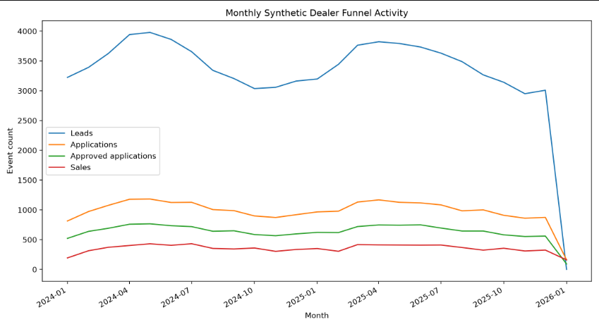

Figure 3.2.2 : Distribution of total sales across dealers
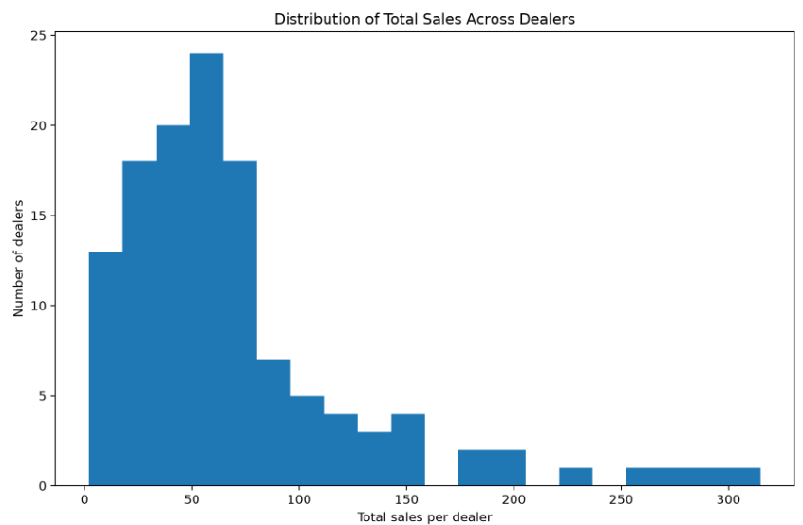

3.2.2 Synthetic Dealer, Lead, Application, and Sales Data
To avoid errors or mismatched columns during the upload, a script was written. The function of the script is to ensure that every CSV file is present before it is finally uploaded. This keeps the testing environment steady and reliable. To ensure reproducibility, the script can also wipe the tables in the database clean and reset the counts before a new upload is done. This ensures every test run starts from a completely identical state. The script then loads the tables in a specific order so that database keys do not break. This ensures that each experimental run starts from the same database state.
The most important part of this loader script is how it aligns data columns. Before pushing data into PostgreSQL, the script reads the database structure and forces the data tables to match it perfectly. It drops any random columns that do not belong, checks that mandatory fields are not blank, and changes data types so that numbers, dates, and text are formatted correctly. Doing these quick checks stops data upload crashes and ensures everything plays nice with the AI system. Once a table loads, the script prints out exactly how many rows were added and checks the database to make sure the counts match perfectly. To give a clear picture of the final database setup, the table below summarizes the exact row and column counts for each table used in this project:
The table below is a summary of Postgres tables used in the Dealer Copilot dataset (row and column counts)

Table 3-2: Showing a summary of Postgres tables used in the Dealer Copilot dataset (row and column counts)
Table Name | Number of Rows | Role
dealers | 125(GH: 30, NG: 40, KE: 30, UG : 25) | Dealers across GH, NG, KE, UG
leads | 82,716 | Leads generated
applications | 24,512 | Loan applications
Approved applications | 15,839 | A subset of applications that have been approved
Rejected applications | 8,6733 | A subset of applications that have been rejected
sales | 8,801 | Sales that come out of the approved application

From the table above, we can tell that there is a relationship between these tables through IDs.

Table 3-3: dealers dataset showing fields with data types
The dealer table is the main table for all the entire dealer network. It is used to identify which dealer did what that is leads , sales , application. The synthetic data contains 125 dealers across Nigeria, Ghana, Kenya and Uganda. The dealers are uniquely identified by their ids and not names

Column name | Data type
Dealer_id | UUID
Dealer_name | character varying
Country | character varying

ii. Leads Table
The leads table begins the funnel in Company C. Each lead is a potential customer generated by a dealer. Potential because they have yet to put in any application and qualify for financing. The dataset is about 82,716 leads between 2024 and 2025.
Table 3-4: leads dataset showing fields with data types
Column name | Data type
Lead_id | UUID
Dealer_id | UUID
Country | character_varying
Lead_date | date
Source | character_varying

iii. Application Table
The next table after leads is application, looking at the analytical funnel. There are about 24,512 applications generated from the leads; out of that 15,000 + approved, and the rest were rejected based on customer eligibility. The application is linked to the leads by the lead_id
Table 3-5: Application table
Column name | Data Type
Application_id | UUID
Lead_id | UUID
Dealer_id | UUID
Country | character_varying
Appplication_date | Date
channel | character_varying
Status | character_varying

iv. Sales Table
Sales is the last thing in the analytical funnel. It is generated from the approved applications. Every sale can be linked to a lead, a dealer, and an approved application.
Table 3-6: Sales table
Column name | Data Type
Sale_id | UUID
Application_id | UUID
Dealer_id | UUID
Sale_date | date
Sale_amount_usd | integer
Financing_bank | character_varying

3.2.3 Database Storage in Postgres
After generating the data, it was stored in a local PostgreSQL database called dealer_ai_copilot. The database layout was designed in two separate layers. Only these four tables are made available for evaluation. That is; dealers , leads, applications and sales. The hidden truth or gold queries are not loaded into the database to avoid exposing them for evaluation.
To ensure that the data is ingested into the PostgreSQL database, a loader script was prepared to create a synthetic dataset. Each dataset is then aligned with the PostgreSQL schema by removing extra columns and enforcing required fields. The tables are inserted in a foreign-key-safe order, and row counts are displayed after loading to verify successful ingestion.

3.4 System Design and Implementation Procedure

3.4.1 System A: Text-to-SQL Baseline
System A is a system LLM-based system. The purpose of this system is for users to ask questions in natural language. The model translates the prompts into SQL queries; the SQL queries is executed against the PostgreSQL database. The system consists of four main parts;
i. The user question
ii. LLM SQL
iii.SQL validation
iv. The execution of the PostgreSQL database.
The architecture uses a Gemini model, which is also used by the two other systems. The model receives user questions, the database schema, and the domain knowledge required to generate a valid query. The system design is configured to execute a single, read-only query. However, before execution, the query goes through safety layers that allow only what is required. The safety layer allows only SELECT and WITH queries. In this system, there are no customized tools, visualization, or natural language interpretation. This means that the user is responsible for interpreting and translating actionable insights. The architecture also stores system metadata for evaluation. It stores token usage, latency, and model version , status of execution, results, and errors
For example, “What are the top-performing dealers in Ghana by applications?” is converted into an SQL query that ranks the dealers by applications and applies a country filter. It will return a table with dealer names in Ghana and their total applications in descending order

Figure 3.X: System A Text-to-SQL Architecture. Source: Author
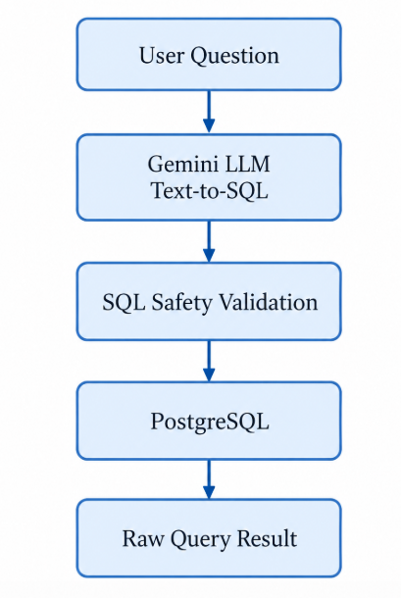

3.4.2 System B : Text-to-SQL with explanation
System B was created to sit between System A and System C when it comes to capability. It is an extension of System A by adding one extra step, which is explanation. It is not just any explanation but a grounded one. From the experiment, System B seeks to compare System A to System C and acts as a control. It performs better than System A but not any better than System C, as there is no planning. System B also uses the same database, model, and domain knowledge as System A. After the results are shown from a successful SQL execution, the model is called a second time, but this time to explain the database results using only the user’s prompt, the SQL query that has been executed, and the results
For instance: the prompt what are the top-performing dealers by application in Ghana?
With this system, it shall receive the same table, but this time convert it into a summary by explaining. While the explanation helps non-technical users, it is limited to the results or rows provided, including incorrect ones. System B does no tool planning, repair SQL, etc. A thorough explanation should not necessarily mean that the query executed is correct.
Figure 3.X: System B Text-to-SQL with Grounded Explanation Architecture. Source: Author
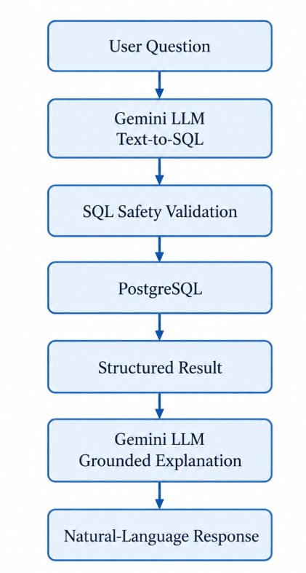

3.4.3 Proposed Agentic System C
The proposed agentic system was implemented to serve as a representation of the most capable analytics structure meant to bridge the technical user gap. Unlike the baseline systems(A and B), the proposed agentic system is flexible and dynamic. It uses the same model as the baseline systems to maintain consistency but follows a more robust agentic flow. System C is implemented with the Google ADK framework. The focus here is the architecture. The user also puts in their prompt; there is an input guard or filter before the prompt is sent to the root agent. The root agent then consults the semantic or knowledge graph to validate or verify against business data, routes it to the appropriate tool, fetches from the Postgres database, and then returns the result. However, a simple prompt may require only a database query.
The core of the proposed system relies on the agent runtime, which uses the Google ADK framework. The agent acts as the central decision-maker. With this structure, the system moves away from template matching and handles a dynamic and wider range of natural language inputs. When a user puts in a prompt, the root agent extracts the intent of the prompt by identifying the key elements like the metrics, the country involved, and the period. The system exposes the custom tools through the MCP layer, which ensures that the appropriate tools are chosen and all results are grounded in the source of truth, which is the PostgreSQL database. As a solution to the limitation of the baseline system, the proposed system is able to run these multiple steps with a single prompt. For example, “What are the top-performing dealers in Ghana by applications?” may involve providing a chart and an explanation or insight. The proposed system is therefore semi-deterministic
The figure below shows the execution flow of the proposed agentic system.

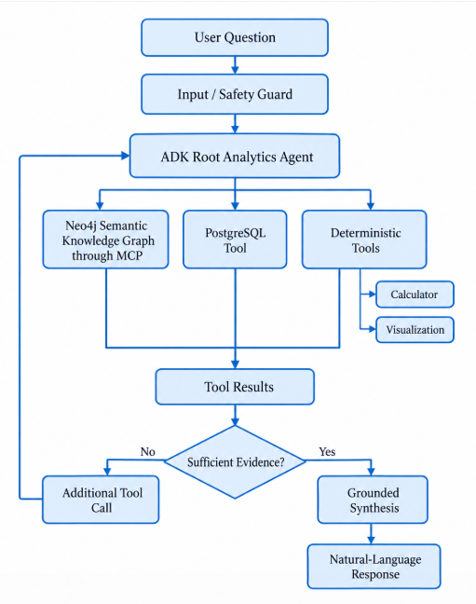

Figure 3-1: Runtime flow of the Dealer AI Copilot

3.4.3.1 Root Agent
The root agent was implemented with a Google ADK framework. The sole purpose of the root agent is to analyze business tasks. The root agent routes the natural language prompt it receives to any custom tool through the MCP. The choice of tools is also determined by the root agent. This means that the root agent is not allowed to do whatever it pleases with the database, but only with the approved tools that have been defined. The allowed and predefined tools are: query_database tool, calculate, create_visualisation, and knowledge-graph read tools. The structure uses a single agent and not a multi-agent system to avoid unnecessary complexities. The root agent is, however, supported with the custom tools to prevent hallucination and provide more grounded answers.

3.4.3.2 Semantic Knowledge Graph with Neo4j
A semantic knowledge graph was also embedded in System C. The knowledge graph provides detailed, explicit explanations of the business and other analytical semantics. It does not contain results or transactional performance data to avoid leakage. The database is the only source of dealer, application, and sales outcomes.
For instance, the knowledge graph shows the business funnel and stores the semantic relationships between the metrics; this helps the root agent provide more accurate results and avoid it from hallucinating and providing generic results when it does not know.

3.4.3.4 PostgreSQL database
The root agent retrieves data strictly from the database through the query_database_tool. But certain guardrails have been put in place to avoid data loses amongst others. The guardrail ensures that the tool only allows for read-only access. It permits only SELECT and WITH queries and does not allow queries that make changes to the database. For example, INSERT, UPDATE, DELETE, DROP, ALTER, TRUNCATE, and CREATE

3.4.3.5 Implementation of Custom Deterministic Tools
This section explains how the various custom tools were built and used in the proposed system. The tools serve as a bridge between the root agent and the database. Instead of allowing the system to always fall back on the LLM for results, these tools were built to make the results more grounded and support the main tasks and dealer analytical objectives of the automobile financing companyThese tools help reduce hallucinations and errors, and provide results in a more structured output.

3.4.3.6. Calculation Tools
One of the custom tools connected to the root agent is the calculation tool. It is meant for arithmetic operations to avoid any calculations that are done with natural language. The arithmetic operations include ratios and percentages, means, medians, sums, etc. The tool does not force the use of every calculation outside SQL. The calculation tool supports the agent with arithmetic calculations that are required after the data retrieval.

3.4.3.7. Visualization Tool
The visualization tool supports visual reporting tasks by producing chart artefacts from time-series metric data. After the root agent retrieves values from the database, the values are passed to the visualization tool only if the task requires a chart. The tool then creates the chart rather than relying on the model to invent a chart. The tool retrieves or receives the relevant metric values for a selected scope, generates a plot using Matplotlib, and saves the result as an image file. The chart tool was implemented to support: reproducible chart generation for fixed inputs, structured chart metadata in tool responses, and integration with the interface for rendering and download.

3.4.3.8 In-session Memory
System C has memory built into the architecture. The memory is short-term and maintains temporary working state during the execution of a single task. This means that the agent not only retains memory of the current task but also the user’s prompt and the results from the knowledge graph, the SQL execution flow, outputs from the database, calculations, errors, and the metadata of the visualization, if any. A session is created for each question used as a benchmark for experimentation, and information from previous questions is not retained to ensure one benchmark task does not influence another. This aims to ensure fairness during evaluation.

3.4.3.9 Agent Behaviour Under Tool Failures or Runtime Issues
During development, runtime issues such as model quota limits and incomplete tool follow-up behaviour were observed in some ADK runs. To support more stable behaviour, the system design emphasised deterministic tools with consistent response formats and clear success or failure indicators.

3.4.3.10 Significance of the Root Agent Design
The root agent implementation is central to the proposed system because it enables flexible natural language interaction while preserving control over data access and computation. The agent provides adaptability in prompt interpretation, while the deterministic tools provide execution reliability.

3.4.3.11 Evaluation Environment
The evaluation environment used during the implementation consisted of:
the user input, the text-to-SQL baseline system, the Google ADK-based agentic runtime,
the MCP PostgreSQL server for controlled read-only data access, and the PostgreSQL database contained the prepared and synthetic dealer analytics dataset.

3.4.3.12 Prompt Set and Task Coverage
A fixed set of natural language prompts was used to evaluate both systems across the task categories defined above. To maintain fairness, prompt wording, country scope, date windows, and expected output requirements were not changed between systems during evaluation.

The table below shows a complete list of evaluation prompts used in the experiments, along with representative examples from each task category referenced in the section. There are 48 benchmark tasks. The 48 tasks were further split into groups to allow fairness. 12 out of the 48 questions were used while building the architecture of the various systems (A, B, and C). They were used to inspect mistakes, debug, and validate whether the evaluator works. Another 36 tasks or questions were set aside. They are supposed to be “unseen” during the development of the systems. They are only tested or run after the systems, model settings and tools are ready and frozen.
These examples illustrate the difference in task handling behaviour before presenting the full evaluation results
Table 3-11: List of evaluation prompts used in the experiments
Task ID | Prompt /Question | Task Category | Expected Output Types
C1_DEV_01 | How many dealers are in Ghana? | Simple numeric retrieval and metric lookup | Numeric value
C1_DEV_02 | How many leads were generated in Nigeria during 2024? | Simple numeric retrieval and metric lookup | Numeric value
C1_TEST_01 | How many sales occurred in Kenya during 2025? | Simple numeric retrieval and metric lookup | Numeric value
C1_TEST_02 | How many applications were approved in Uganda during 2024? | Simple numeric retrieval and metric lookup | Numeric total
C1_TEST_03 | What was the total sales revenue in Ghana for 2025? | Simple numeric retrieval and metric lookup | Numeric total
C1_TEST_04 | How many leads generated in Nigeria were referred in 2025? | Simple numeric retrieval and metric lookup | Numeric total
C1_TEST_05 | How many applications were submitted by the bank partners channel in Kenya for 2024 | Simple numeric retrieval and metric lookup | Numeric total
C1_TEST_06 | Compare the monthly sales trend versus the monthly applications trend in Kenya from 2023-01-01 to 2023-12-31 | Trend comparison | Trend table (two metrics)
C2_DEV_01 | How many applications in Ghana were approved in the first quarter of 2025? | Metric lookup and date filter | Numeric value/lookup
C2_DEV_02 | What was the total revenue from sales financed from Bank- A in Nigeria during the second half of 2024? | Metric lookup and date filter | Numeric value/lookup
C2_TEST_01 | How many applications were rejected by bank partners in Kenya during the second quarter of 2025? | Filtered aggregation | Numeric value/lookup
C2_TEST_02 | How many leads were generated in Uganda in the fourth quarter of 2024 | Filtered aggregation | Numeric value/lookup
C2_TEST_03  C2_TEST_04  C2_TEST_05  C2_TEST_06 | How many dealer applications were approved in Nigeria in the third quarter of 2025?  How many sales in Ghana were financed from Bank_D during the first quarter of 2024  How many marketplace leads were generated in Kenya in the first half of 2025?  What was the total revenue from sales financed by Bank-B in Uganda in the fourth quarter of 2025? | Filtered aggregation  Filtered aggregation  Filtered aggregation  Filtered aggregation | Numeric value/lookup  Numeric value/lookup  Numeric value/lookup  Numeric value/lookup
C3_DEV_01 | Which five dealers in Ghana generated the highest number of applications during 2025? Provide the dealer name and number of applications | Ranking / Comparison | Ranked table
C3_DEV_02 | Which five dealers in Kenya generated the least leads in 2024? Return dealer name and lead count, including dealers with zero leads if any. | Ranking / Comparison | Ranked table
C3_TEST_01 | Which three dealers in Nigeria generated the highest number of sales in 2024? Provide the dealer name, sales count, and revenue. | Ranking / Comparison | Ranked table
C3_TEST_02 | Which five dealers in Uganda recorded the highest sales in 2025? Provide the dealer name and sales count. | Ranking / Comparison | Ranked table
C3_TEST_03 | Rank the four countries from highest to lowest by number of leads generated in 2025. | Ranking / Comparison | Ranked table
C3_TEST_04 | Which five dealers in Kenya generated the most leads in 2024? Return dealer name and referral-lead count. | Ranking / Comparison | Ranked table
C3_TEST_05 | Which five dealers in Nigeria recorded the least number of sales during 2025? Provide dealer name and sales count, including dealers with zero sales if any. | Ranking / Comparison | Ranked table
C3_TEST_06 | Rank the financing banks from highest to lowest by total sales in 2025. Provide the bank name, sales count, and revenue. | Ranking / Comparison | Ranked table
C4_DEV_01 | Of the leads generated in Ghana in 2025, what percentage eventually produced an application? Report the lead count, resulting application count, and percentage. | Derived Analytics | calculated metric
C4_DEV_02 | What percentage of applications submitted in Uganda during 2024 were approved? Report total applications, approved applications, and the approval percentage. | Derived Analytics | calculated metric
C4_TEST_01 | Of the applications approved in Nigeria in 2025, what percentage eventually resulted in a sale? | Derived Analytics | calculated metric
C4_TEST_02 | What was the average sale value in Kenya in 2025? Report the number of sales and the average sale value in USD. | Derived Analytics | calculated metric
C4_TEST_03 | Of the leads generated in Ghana in 2024, what percentage eventually translated in a sale? Report the lead count, sales count, and percentage. | Derived Analytics | calculated metric
C4_TEST_04 | What percentage of applications were submitted in Nigeria in 2025 were rejected? Report total applications, rejected applications, and the rejection percentage. | Derived Analytics | calculated metric
C4_TEST_05 | What was the average revenue per sale in Uganda in 2025? Report total sales, total revenue, and revenue per sale. | Derived Analytics | calculated metric
C4_TEST_06 | By what percentage did the number of sales in Kenya change from 2024 to 2025? Report sales in both years and the percentage change. | Derived Analytics | calculated metric
C5_DEV_01 | Show the number of leads and sales for each month in Kenya during 2025. | Multi-Metric | Time-series table
C5_DEV_02 | For each quarter of 2024 in Uganda, report applications, applications that were approved, and the application approval percentage. | Multi-Metric | Time-series table
C5_TEST_01 | For each month of 2025 in Nigeria, report applications and sales, and identify the month with the highest sales count. | Multi-Metric | Time-series analysis
C5_TEST_02 | For each quarter of 2025 in Ghana, report sales count and revenue, and identify the quarter with the highest revenue. | Multi-Metric | Time-series analysis
C5_TEST_03 | For each month of 2024 in Kenya, compare the number of leads generated with the number of applications submitted in that month, calculate applications divided by leads as a percentage, and identify the month with the highest percentage. | Multi-Metric | Time-series analysis
C5_TEST_04 | For each month of 2025 in Uganda, report applications, approved applications, and sales. | Multi-Metric | Time-series table
C5_TEST_05 | For every country and quarter in 2025, report sales count and total revenue. | Multi-Metric | Multi-series table
C5_TEST_06 | Compare Nigeria's monthly sales in 2024 with the same months in 2025. Report the month, 2024 sales, 2025 sales, and the difference between the two years. | Multi-Metric | Time-series comparison
C6_DEV_01 | Looking at the dealers with at least 200 leads generated in 2025, identify the five dealers with the highest lead volume whose eventual lead-to-sale percentage was below the overall median dealer lead-to-sale percentage for 2025 lead cohorts. Return dealer name, country, leads, applications, approved applications, sales, lead-to-sale percentage | Business Analytics | Ranked derived table + explanation
C6_DEV_02 | Create a month-on-month comparison of applications and sales in Kenya during 2025, calculate the gap between applications and sales, identify the month with the largest gap, and visualize the comparison. | Business Analytics | Time-series analysis + visualization
C6_TEST_01 | Which of the dealers has at least 150 leads generated in 2025? Identify the five dealers with the highest number of leads that led to sales . For each dealer, report leads, applications, approved applications, sales, lead-to-application percentage, application-approval percentage, approved-to-sale percentage, and identify the weakest funnel stage. Briefly explain the result. | Business Analytics | Ranked table + explanation
C6_TEST_02 | Compare the four countries using 2025 lead cohorts. For leads generated in 2025, report the number of leads, applications, approved applications, and sales. | Business Analytics | Comparative analysis + explanation
C6_TEST_03 | For each quarterly lead cohort in 2025 in Nigeria, report leads, eventual applications, eventual approved applications, eventual sales, lead-to-application percentage, application-approval percentage, and approved-to-sale percentage. Identify the weakest funnel stage in each quarter and the quarter with the highest eventual lead-to-sale percentage. Summarize the pattern. | Business Analytics | Time-series diagnostic + explanation
C6_TEST_04 | For leads generated in December 2025, compare each country by the number of leads, the number that eventually produced an application, the number that eventually produced a sale, the lead-to-application percentage, and the lead-to-sale percentage. Identify the country with the highest lead-to-sale percentage. | Business Analytics | comparison
C6_TEST_05 | Among dealers with at least 150 leads generated in both 2024 and 2025, identify the five dealers whose eventual lead-to-sale percentage improved the most from the 2024 lead cohort to the 2025 lead cohort. For each year, follow the leads to any resulting sales. Report dealer name, country, leads, and resulting sales for each year, both yearly lead-to-sale percentages, and the percentage-point improvement. Briefly explain what the ranking means. | Business Analytics | Year-over-year diagnostic + explanation
C6_TEST_06 | For each month of 2025 in Uganda, report applications, sales, and revenue. Identify the month with the highest revenue and the month with the largest gap between applications and sales, visualize the monthly comparison, and summarize the main pattern. | Business Analytics | Time-series analysis + visualization + explanation

This prompt set list increases the chances of observing differences in scope adherence and efficiency between the baseline and the proposed agentic AI copilot, especially with paraphrased or multi-part prompts. The tasks were grouped into categories based on the main function required from the system to test robustness to variation in wording.
1. Metric lookup and summary tasks
These tasks test whether the system can retrieve totals or summary values for key performance metrics such as listings, leads, applications, inventory, and sales within a specified country and time period.
2. Ranking and comparison tasks
These tasks test whether the system can rank dealers, for example, top or bottom performers, or compare performance across dealers, countries, or time periods.
3. Trend analysis tasks
These tasks require the system to retrieve and describe changes in a metric over time, such as monthly applications, sales trends, or changes in lead volume across a selected period.
4. Chart generation tasks
These tasks test whether the system can correctly generate charts for selected metrics using the required filters, such as country and date range, and the correct time resolution, such as daily, weekly, or monthly.
5. Multi-step tasks (tool chaining)
Some tasks, especially the complex and not defined ones, require multi-step tasks or chaining the custom tools. These tasks were included in the assessment of both systems to test their robustness and the system's ability to coordinate its components and make the best choice amongst the tools whilst executing a task.
To ensure consistency, each task was mapped to an expected output and output type. Some of the output types are totals, trends, score tables, and charts
Where applicable, correctness was verified against direct SQL outputs from the PostgreSQL database. The evaluation metrics were selected to measure performance under the same data conditions across both the baseline and the proposed agentic system. The metrics were chosen to reflect both system performance and human focus as well. However, because the study compares three systems with obviously different capacities and levels, not one single evaluation metric will be sufficient. Some of my focus areas for evaluation are: accuracy/correctness, task completion, efficiency, reliability, transparency, and user performance. These areas are in connection with the research questions. For the main research focus, which is bridging the reliance on technical expertise for data access, the method of evaluation is the use of humans to evaluate whether the users arrived at the accurate result. The human evaluators have either technical or non-technical backgrounds. For instance, if there is a smaller gap while evaluating system C with non-technical and technical users, that only means that agentic analytics actually helps non-technical users.
- Metric 1: Factual correctness, achieve full task success and completion of component RQ1)
Factual correctness check if the system returns correct numerical or categorical values against the source of truth. Full task success looks at whether the system ticked all the components of a prompt whilst answering it, whilst component completion checks that the required components are also completely achieved. For instance, if one or more of the systems produces four out of five required outputs, it means the component completion is not complete or partial. Another thing this metric looks at is measuring how complex tasks are.

- Metric 2: Grounded explanation and Visualisation Correctness(RQ2)
This metric examines the additional value that System B and C have, which is explanation. Did the system clearly explain the results, was the explanation backed by the data from the database, and void of any wrong claims? For tasks that generate charts, did the charts provide correct values, timelines, variables, and correct labels? The metric helps prove the essence of the visualization capability of system C and the grounded explanation of system B.
- Metric 3: User Performance and bridging the technical expertise gap (RQ3)
This metric measures how technical and non-technical users use all three systems. Do the users arrive at the accurate business conclusion or decision after using the systems? Does advanced analytics reduce the amount of technical expertise and effort to access and understand data, especially in complex business environments? This evaluation checks individually for non-technical users and technical users, and the difference is the gap between the two types of users. This metric also checks how trustworthy the systems are
$G_{S}$ $=y_{technical}-$ $y_{non-technical}$
- $G_{S}$ represent the gap measures across all three systems; y represents the performance of the various participants, who are either technical or non-technical.
- Metric 4: Efficiency, Reliability, and Recovery.
This metric focuses on the trade-offs among the various systems. Are the systems reliable
and efficient? Pass@1 is used to measure reliability. This measure checks if, on the first
attempt, these systems can provide accurate results, hence the name Pass@1. For
efficiency, factors such as latency, number of model calls, and use of tokens are
considered. It also answers the question: do the extra capabilities of the agent result in
better performance while using extra computational effort?

All these metrics come together to evaluate these systems properly, ensuring that their purpose is met and that users can understand and appreciate the results provided. Are the results even correct? And are they useful to both technical and non-technical users?

3.5 Ground Truth and Verification Procedure
Looking at tasks that produce only numeric outputs, for instance, totals, time-trend series, and values, the correctness was checked by comparing the outputs to the ground truth, which is the PostgreSQL database using the same filters and demands in the prompts. This was to ensure that both systems were assessed by the same database or source of truth. Below were the checks involved in assessing both systems:
- If the actual country filter was applied,
- If the actual metrics involved were chosen,
- If the actual time period (daily, weekly, or monthly) was chosen, and finally,
- If the actual date or date range was applied, whether the requested date range was respected, and
When it came to the tasks that required ranking, there were certain verifications put in place as well. It required checking the order in which the results came in and the correct number. When it came to time series tasks, I not only checked the correct values returned but also the order in which the time period came in. An output or result was only considered correct if it matched only the source of truth, which is the PostgreSQL database, and also within the correct scope. was within the requested scope of the task. Results that seemed correct but ignored some filters or used incorrect metrics and aggregation levels were not treated as incorrect. This was very important because good analytics require full transparency and truth, which will ensure good decision-making and trust in companies. For transparency, the verification queries were executed directly against the same PostgreSQL database used by both systems during evaluation. This ensured consistency in validation and reduced the risk of comparing outputs against a different data snapshot or altered query conditions.

3.8 Tools and Software
In this study, certain tools and libraries helped with various aspects such as data generation, managing the database, embedding the language model, the agent architecture, evaluating the system, experimentation, and semantic knowledge. The main development mainly used Python and PostgreSQL for database creation and management, and Neo4j for the semantic knowledge.

3.8.1 Development tools and libraries
The proposed system was implemented in Python and evaluated using the following tools and software.
Python (primary programming language): Python was used to implement the agent data generation, database loading, system evaluation, architecture, pipeline, tool wrappers, database access logic, chart generation, and the user interface integration.
MCP (mcp >=1.00)
The MCP package was used to expose the knowledge graph’s capabilities to the agent. This helped the agent retrieve more knowledge about the business and become more grounded in its responses. The Model Context Protocol (MCP) server layer allows the knowledge graph in a safe and controlled manner.

Psycopg:
psycopg was used as the PostgreSQL database driver for connecting to the Postgres database and executing read-only SQL queries for filtering, aggregation, ranking, and time-window analysis.
Google ADK (google-adk == 1.21.0) :
Google ADK is an agentic AI framework used for the implementation of this project. The framework includes an agent layer, prompt interpretation, tool planning, and calling
Matplotlib (matplotlib>=3.10.8):
Matplotlib was used in the implementation of the chart tool to generate visual outputs and charts, as well as make them exportable for display in the user interface.
Google Gen AI SDK:
The Google Gen AI SDK was used in this study to gain access to the Gemini models used across all three systems.
Neo4j:
This library was used to implement the semantic knowledge graph for system C. The graph keeps all business decisions and information, such as metric definitions, relationships between these metrics, business definitions, and relationships between database schemas
Virtual environment (dealerai-env):
A Python virtual environment named .dealerai-env was used to accommodate all dependencies specifically for this project and maintain a reproducible development setup.

PostgreSQL (dealer_ai database):
PostgreSQL was used as the primary and only relational database for storing the tables, event-level records, and analytical data used by the tools.
PgAdmin:
PgAdmin was used as a graphical interface for database administration, SQL execution, and inspection of database tables during development and validation.
Pandas (2.0.0):
Pandas was used for preparing and cleaning the data, ensuring schema alignment, aggregation checks, and formatting query results, which are relevant before presenting outputs.
Gemini 3.5-Flash-Lite: LLM model for development and experimentation

3.10 Ethical and Responsible Data Use
The design of the systems factored in ethical and responsible data principles, especially because it involves analytics and reporting, LLM-assisted query handling, and database-backed reporting.
One of the most important considerations in this project was data privacy and confidentiality. Due to data privacy and sensitivity, the actual dealer operations data was not made available for use in this project. However, the study adopted the use of synthesized data to reflect the business’s operational data. This ensured that private clients, dealer, and financial records were kept confidential whilst still allowing for this experimentation. All systems were developed and tested on-prem. After cleaning and synthesising the data, a pipeline was built and stored in a local PostgreSQL instance and inspected through pgAdmin during controlled development and testing. The system was not connected to a live production database.
Another ethically responsible AI consideration I considered is the role of these systems in decision-making. The proposed systems and baseline are designed as an analytics and reporting decision-support tool, but not as an autonomous decision-maker. It shows that its intentions are intended to assist human users in understanding dealer performance and not to replace managerial judgment or directly trigger operational actions without review.
Finally, safety constraints and security measures are built into the system design to reduce harm and ensure safe and controlled behaviour. The database can only be accessed via read-only access, and the tool execution is limited only to certain approved analytical functions, whilst the outputs are grounded in structured tools. These design choices improve traceability, reduce the risk of unsupported results, and support accountability in the use of the system.

3.11 Summary
This chapter explained in detail the methodology used in the study. It described how the data was generated, how the data was transformed, how the data was stored and prepared in the dealer AI PostgreSQL database, and how key dealer activity metrics were defined for analytics and reporting tasks.
The chapter also described the two baseline approaches and the proposed agentic AI framework, including the role of the root agent, the deterministic tool layer, the MCP and the read-only database access design, all evaluated with about 36 benchmark questions. In addition, it outlined the tools and software used in development, the runtime environment, and the custom tools implemented for safe and grounded analytics execution.
Finally, the chapter established the evaluation strategy by defining the task categories, the evaluation metrics, and the comparison setup used to assess the baselines and agentic systems under the same data conditions. The next chapter presents the results from the implementation and analysis of the systems.

RESULTS
This chapter presents detailed results of the evaluation comparing the LLM-based Text-to-SQL system and the proposed agentic system. The comparison was carried out across 13 defined prompts and the evaluation procedure described in Chapter Four. Both systems were tested under the same data conditions, the same prompt wording, and the same read-only access constraints. This chapter aims to show how both systems performed across the three evaluation dimensions defined earlier: 1) accuracy of numeric outputs, 2) task completion and scope adherence, and 3) efficiency measured by the number of tool calls or processing steps. The results are presented to show not only whether each system produced an answer, but also whether the answer was correct, complete, and operationally useful within the requested scope. The goal of this chapter is to provide measurable evidence of how the agentic design compares with deterministic rule-based routing on dealer analytics and reporting tasks.

4.1 Overall Summary of Results
The table below shows the overall evaluation results across 13 prompts
Table 4-1: Evaluation results across 13 prompts
Metric | Baseline System | Proposed Agentic System
Numeric accuracy rate (%) | 61.5% | 100.0%
Full completion rate (%) | 53.8% | 100.0%
Average completion score (0 to 1) | 0.69 | 1.0
Mean steps or tool calls per task | 1.85 | 2.2
Median steps or tool calls per task | 2 | 2
Based on the 13 prompts as shown above, the proposed agentic system performed better than the baseline system. The baseline performed well on just simple retrieval and ranking tasks such as dealer counts and total applications. However, the baseline’s performance reduced when the prompts required either a scoring, chart , trend comparison or explanatory analysis. The proposed system was able to tackle complex analytical prompts. In terms of efficiency, the proposed recorded a higher processing steps per tasks because it required more tool calls, performed tool-based reasoning and execution.

4.1.1 Results for Accuracy of Numeric Outputs (RQ1)
Accuracy of numeric outputs was assessed by comparing the responses of both systems against PostgreSQL ground truth under the same filters, including country, metric, date range, and time resolution, where applicable. For tasks involving counts, totals, rankings, and time-series values, the baseline system and the proposed agentic Dealer AI Copilot generally returned the same numeric results when the prompt matched a supported query type.
This outcome is not unexpected, because both systems relied on the same underlying PostgreSQL database and operated under the same read-only constraints. In many straightforward analytics tasks, such as total applications, total leads, dealer counts, and simple score-based rankings, the proposed system was able to retrieve the correct values better than the baseline system. The baseline system performed well on very simple prompts that required counting, totals, and ranking tasks but reduced in performance when it came to scoring of the dealers, comparison logic etc. The baseline achieved a result of 61.5% numeric accuracy as it was able to answer 8 out of the 13 prompts correctly, whilst the proposed was able to achieve a numeric accuracy of 100% because it was able to answer all 13 prompts correctly.
This tells us that the LLM-to-SQL baseline can retrieve simple numeric values but is not reliable when it comes to complex and multi-step tasks. In this study, numeric accuracy only confirms whether the returned values were correct for the part of the task that was executed. The numeric accuracy does not, on its own, prove if the full request made by the user was completed, whether all requested metrics were included, or whether the system preserved the complete analytical scope of the prompt. For this reason, numeric accuracy is interpreted together with task completion and scope adherence in the following section. The screenshots in this section shows figures included in this section show representative examples of numerically correct outputs from both systems. These examples demonstrate that, for very simple and well-defined analytics requests, the proposed agentic system did not necessarily improve the numeric result itself but rather aimed to improve flexibility, response quality, and handling of more complex prompt structures, or aimed to be another alternative.
The figure below shows both the baseline and proposed system results for a total applications query in Ghana from 2023-01-01 to 2023-08-31. Both systems returned the same numeric total under the same prompt and filter conditions.
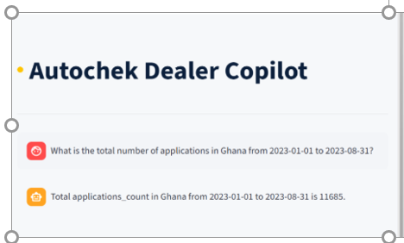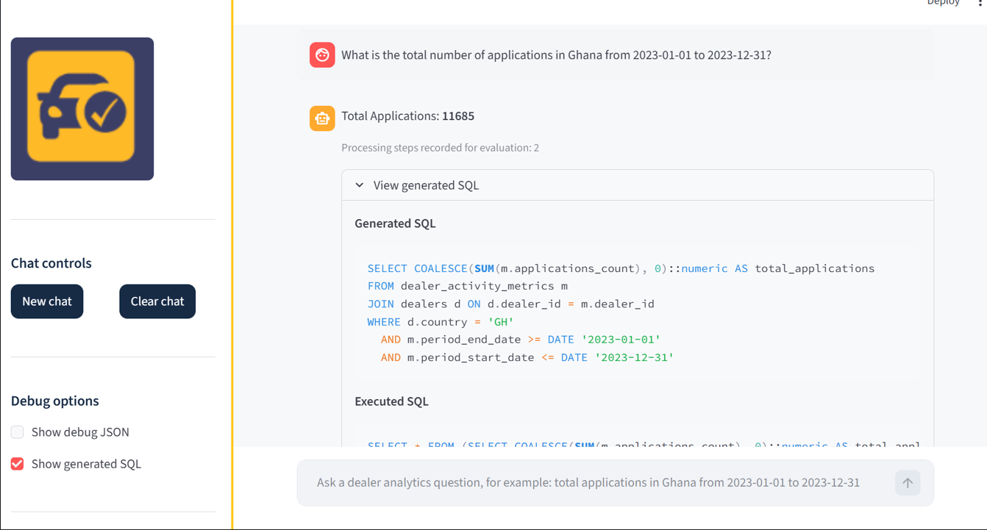
Figure 4-1: Baseline and proposed system outputs for a total applications query in Ghana

The proposed and baseline systems both returned the same value of 11,685. This tells us that for simple and clearly stated tasks, both systems were able to retrieve the accurate results, and this is because both systems are under the same data conditions. This result is consistent with the broader pattern observed in the evaluation. In this case, the proposed system did not necessarily improve the value returned but rather provided an alternative system that is also intended to support more flexible prompt handling and richer response behaviour in more complex tasks.
This figure helps you support these claims of RQ1; both systems can be equally accurate on straightforward numeric tasks
The proposed system is not automatically more accurate just because it is agentic
The real difference is likely to be more apparent in:
- task completion
- scope adherence
- handling of complex prompts
However, similarity in numeric outputs on simple queries does not imply equal overall performance. As shown in the next section, the clearer differences between the two systems emerged in task completion and scope adherence, particularly for more complex or multi-part prompts.
The figure below presents an illustrative example of the same evaluation prompt executed on both the baseline system and the proposed agentic Dealer AI Copilot under identical input conditions.
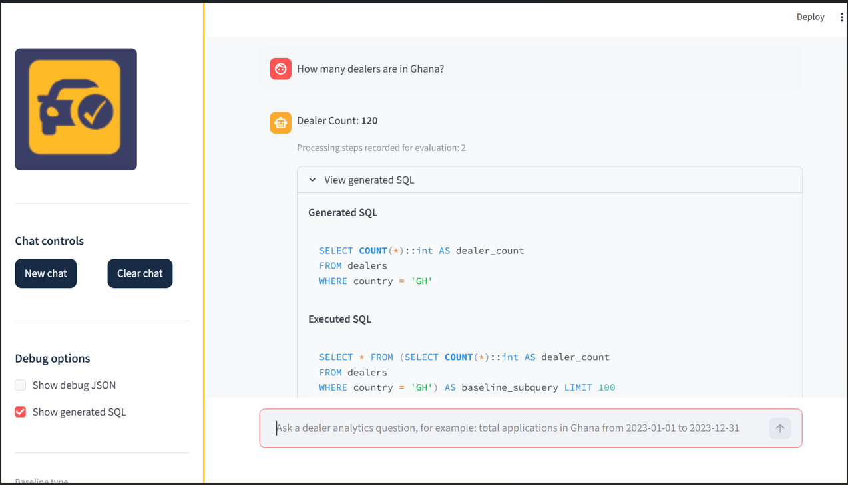
Figure 4-2: Screenshot from baseline model system output for “How many dealers are in Ghana”

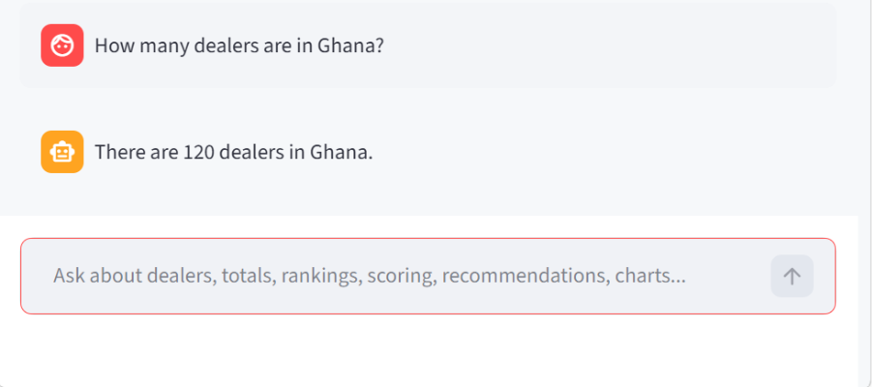
Figure 4-3: Screenshot from proposed system output for “How many dealers are in Ghana”
The figure below shows an example of a trend comparison prompt executed on the proposed agentic Dealer Copilot and the baseline system under identical data conditions.

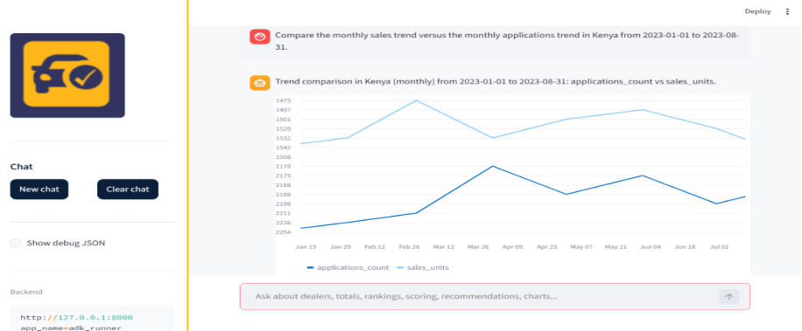
Figure 4-4: Trend comparison prompt executed on the proposed agentic Dealer Copilot

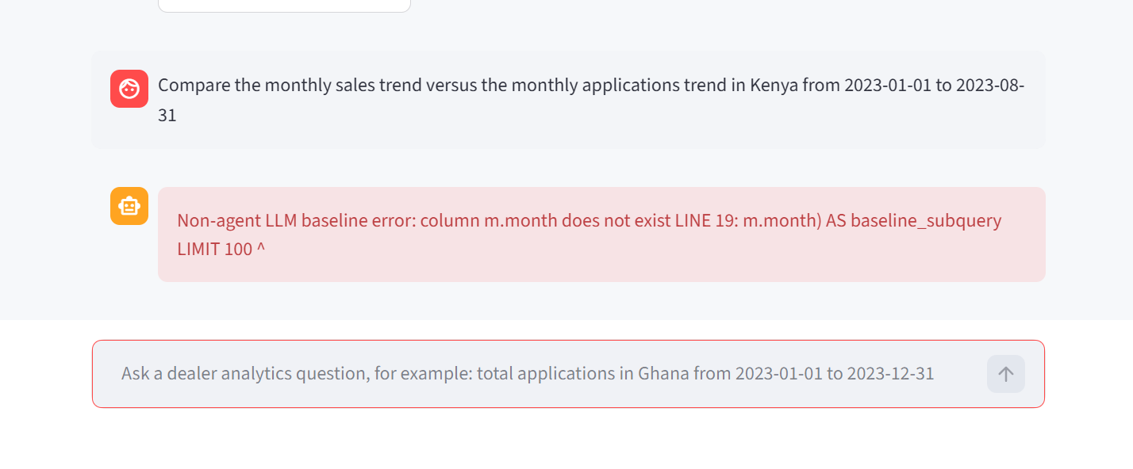
Figure 4-5: Trend comparison prompt executed on the baseline system
Both systems produce different outputs for this task. The baseline failed to produce any valid result. It didn’t generate a correct monthly aggregation using the date field but instead chose a non-existent column “m.month,” which caused the SQL query to fail while executing. This shows us one of the key limitations of LLM-to-SQL prompting. The model may hallucinate certain schema fields when tackling complex tasks. However, the proposed system was able to use the custom tools to provide results within the requested scope.

4.1.2 Results for Task Completion and Scope Adherence (RQ2)
This metric looks at whether both systems produced the expected or correct output and output type, and whether they preserved the full analytical scope requested by the user’s prompt. A task was considered completed if (1) it was able to return the correct output format, for instance, numeric total, ranking, chart, time period etc and (2) correctly applied the requested scope, including the country, metric, date range, and time resolution where relevant. Outputs that were partially correct but missed key parts of the prompt, such as returning only one metric when two were requested, were treated as partial completions. This metric showed bigger differences between the baseline and proposed system than numeric accuracy alone. The baseline system achieved 53.8% in task completion rate. It was able to achieve a score of 1.0 for only 7 prompts out of 13. Partial task completion was scored as 0.5 and therefore, was not counted as fully completed for this metric. The partial completion will be taken care of by the average completion score.
The task completion rate tells us that the baseline system performed well on simple tasks where the prompts could be satisfied through just a single SQL query. Examples of these prompts are total applications, total leads, dealer counts etc. However, the baseline was less reliable when the prompt demanded a more direct retrieval.
The figure below shows the outputs for the prompt “Generate a chart comparing the monthly sales trend and monthly applications trend in Kenya from 2023-01-01 to 2023-08-31 and summarise the difference.” 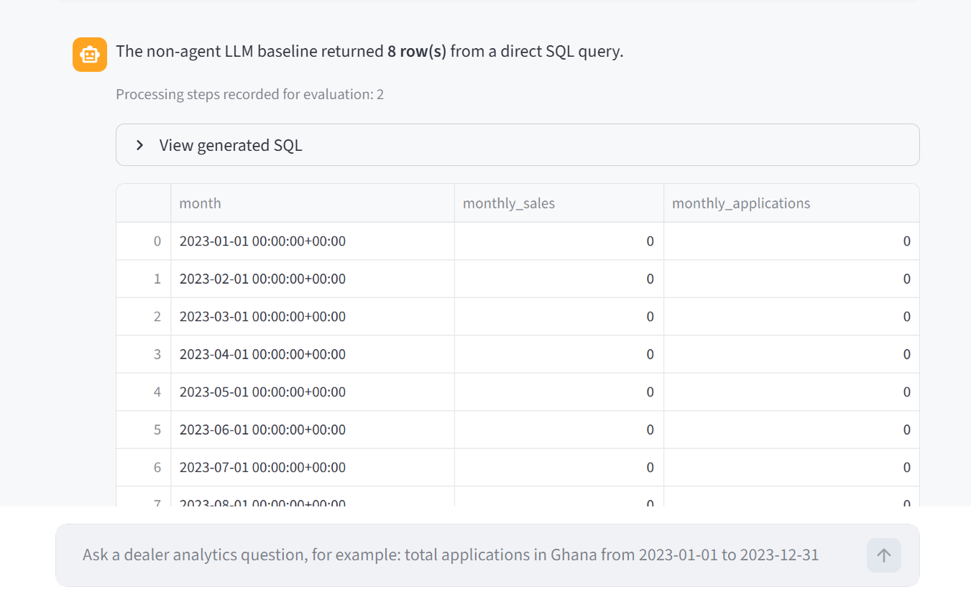
Figure 4-6: Baseline outputs for the prompt “Generate a chart comparing the monthly sales trend and monthly applications trend
The baseline system did not generate a chart but it returned a table containing monthly sales and monthly applications values. The returned values were also incomplete and did not provide the requested visualization or analytical comparison. Therefore, this task was treated as incomplete for the baseline system.

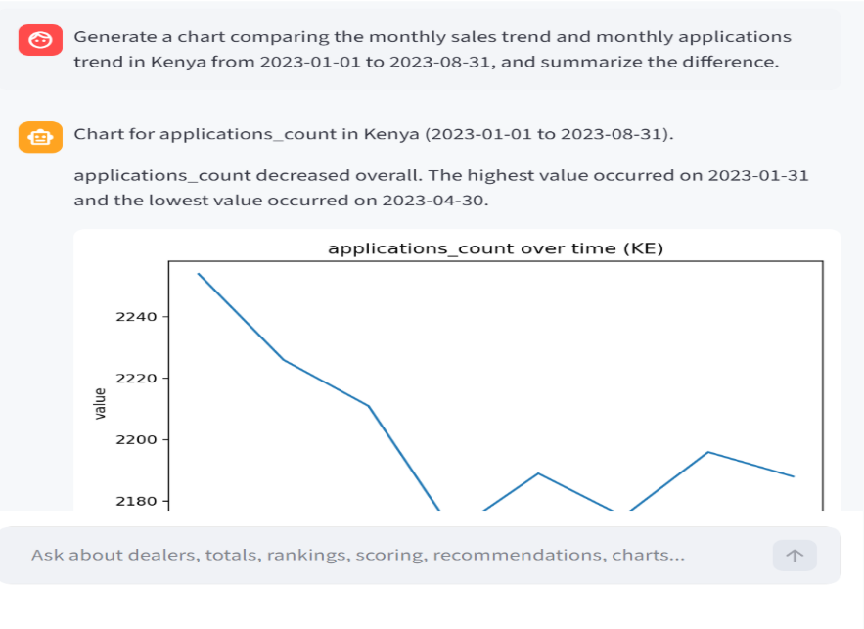
Figure 4-7: Proposed System outputs for the prompt “Generate a chart comparing the monthly sales trend and monthly applications trend
The proposed system was able to generate a chart and add a short text summary describing the application trend. Unlike the baseline, which only relies on an SQL query, the proposed system was able to generate a visual output and summary, which is within the requested scope of the task.
The results above prove that task completion is a more useful and relevant measure than numeric accuracy alone. Returning a table is not enough when a user requests for a chart.

4.1.2.1 Average completion score (a subset of task completion rate)
This metric not only looks at whether the system was able to complete a task, but how fully it completed the task, hence the reason why it is a subset of the task completion rate. It looks at whether it answered the prompts partially or it failed entirely. Full completion rate is awarded a 1.0, partial completion is 0.5, and failed or not useful is 0.0.
Below are the scores both systems were awarded across the 13 prompts

Task completion for baseline system
Task ID | Prompt /Question | Completion score | Reason
T1 | What is the total number of applications in Ghana from 2023-01-01 to 2023-12-31? | 1.0 | It fully completed the task
T2 | How many dealers are in Ghana? | 1.0 | It fully completed the task
T3 | What is the total number of leads in Kenya from 2023 01-01 to 2023-12-31? | 1.0 | It fully completed the task
T4 | What is the total number of sales units in Kenya from 2023 01-01 to 2023-12-31? | 1.0 | It fully completed the task
T5 | Score dealers in Ghana from 2023 01-01 to 2023-12-31? | 0.5 | Retrieved the raw metrics but could not score the dealers
T6 | Show the top 5 dealers in Ghana by applications from 2023 01-01 to 2023-12-31? | 1.0 | It fully completed the task
T7 | Show the bottom 5 dealers in Ghana by applications from 2023 01-01 to 2023-12-31? | 1.0 | It fully completed the task
T8 | Compare the monthly sales trend versus the monthly applications trend in Kenya from 2023-01-01 to 2023-12-31 | 0.0 | Eventhough, it was able to extract the metrics. It was unable to compare the metrics and generate a chart
T9 | Generate a chart comparing the monthly sales trend and the monthly applications trend in Kenya from 2023-01-01 to 2023-12-31 | 0.0 | Unable to generate a chart
T10 | Plot the monthly applications trend in Ghana from 2023-01-01 to 2023-12-31 and summarise it in one sentence | 0.5 | Returned the value but was unable to generate a chart
T11 | In 2023, how many applications did Ghana record? | 1.0 | Completed the task
T12 | Which dealers are the lowest performers by applications in Kenya for 2023? Show the bottom | 1.0 | Completed the task
T13 | Compare sales and applications in Kenya month by month in 2023 and explain which metric is stronger overall | 0.0 | Was unable to generate a chart

From the table, the total score came up to 9.0. Therefore, the average completion score is 9.0/13 = 0.69. This tells us that the baseline did not completely fail or achieve the various tasks overall. For simple tasks, it achieved a score of 1.0, but for complex tasks it achieved either a 0.5 or a 0.0 score. However, the proposed system was able to achieve a score of 13/13, making it 1.0 overall. The average completion is score is higher than the task completion rate because the average completion score considered partial completions too.

4.1.3 Results for Efficiency Trade-Off (RQ3)
The efficiency was evaluated as the number of tool calls for the proposed system and the number of comparable processing steps for the baseline system. Unlike the completion metric, which focuses on whether the full prompt was satisfied, the efficiency metric looks at the operational effort required to produce a response. This metric was included to examine the trade-off between the baseline system’s execution path and additional requirements of the proposed agentic architecture. Across the 13 prompts evaluated, the baseline system recorded a mean of 1.85 steps per task and a median of 2, while the proposed agentic system recorded a mean of 2.2 tool calls per task and a median of 2. These results show that the proposed system generally uses more tools than the baseline. However, the fact that the baseline system recorded a lower step count does not mean that the baseline is any better. This is because the proposed system requires more effort than the baseline especially for complex tasks. For example, the baseline failed to generate charts when requested.

4.2 Efficiency (Tool Calls or Processing Steps)
Efficiency was measured by counting the number of tool calls or processing steps required to complete each evaluation task. This metric captures the practical cost of producing an answer, since in real operational settings, latency and computational overhead matter. In general, the baseline system was more efficient on simple prompts because it uses a direct LLM-to-SQL process, making the baseline lightweight for simple prompts.
The proposed agentic Dealer AI Copilot sometimes required additional steps because it involves tool selection and orchestration across the tool layer. For example, a request that produced a chart and summary may involve (1) retrieving trend data, (2) generating a plot artefact, and (3) composing a natural language explanation from structured outputs. As a result, the proposed system can incur a small efficiency cost in exchange for richer responses and greater flexibility, especially on tasks that require tool chaining.
In the real-world, efficiency should not only mean fewer steps but should also consider if the system produced a complete and useful answer. For instance, a response that requires fewer steps but is unable to generate charts or omits scoring logic will create more work for the users. For this reason, the proposed agentic system’s custom tools are justified because it improves accuracy, adherence of tasks and usability.

Chapter 5

DISCUSSION

5.1 Discussion
This study aimed to design and evaluate a Dealer AI Copilot prototype for dealer performance analytics and reporting using an agentic architecture built around deterministic tools and controlled database access. The results from Chapter Four show us the evidence for discussing the strengths and trade-offs of the agentic AI copilot design compared to the non-agent LLM-based Text-to-SQL. One of my key findings is that the baseline system is effective for simple and well-defined tasks such as totals, ranking, etc. This shows us that the direct LLM-to-SQL concept is more useful when a natural language prompt is translated into an SQL query that can be executed.
However, using the same design for tasks that require a more complex combination, multiple requirements, and requests is not suitable. For instance, comparing two metrics to see the trends over time, scoring the dealers, generating charts, and creating a summary.
For example, when asked to generate a chart comparing monthly sales and application trends, it returned a table instead. The proposed agentic AI copilot was designed and implemented to address these challenges and complex situations. In the agentic design, the root agent (ADK runtime) interprets the user’s prompt and selects an appropriate tool or tool sequence, while deterministic tools execute read-only retrieval and reporting operations. This separation improves usability by allowing users to ask questions in more natural forms while still constraining outputs to grounded results derived from the database.
The evaluation done above proves that there's a huge value in the custom tools for this project, and the major value the tools provide is that they reduce hallucination and errors. Instead of relying solely on the answers generated by the model, both the baseline and agentic systems produced numeric outputs by querying PostgreSQL through controlled interfaces. This ensures that values such as totals, counts, and time-series points are traceable to the underlying data rather than generated from language modelling. In practice, this makes correctness verification feasible and supports auditability for analytics reporting. At the same time, the results highlight that the agentic architectures introduce trade-offs. The proposed system may require additional steps, such as tool orchestration or supplementary summarization, which can increase latency compared with the baseline system. Furthermore, the results proved that improved output richness does not automatically guarantee complete scope adherence. In one multi-part comparison task, the proposed system produced a more informative response by adding a summary, but it still reduced the full request to a single-metric output, indicating that stronger scope-tracking and parameter enforcement are needed for complex prompts.
Overall, the findings suggest that an agentic design supported by deterministic tools is a practical approach for dealer analytics support, particularly when users ask varied business questions and data access must remain safe, read-only, and auditable. However, the system’s value depends on careful tool routing, scope adherence, and efficiency-aware orchestration rather than agentic behaviour alone.

Chapter 6

CONCLUSION AND RECOMMENDATION

6.1 Conclusion
This study focused on the design, implementation, and evaluation of a Dealer AI Copilot for dealer performance analytics and reporting. The system is a combination of an LLM root agent, custom-built tools, and an MCP connected to the database to allow controlled access to operational data, and finally, a user interface built with Streamlit where users put in their prompts in plain English.
The system is broken into layers: the root agent focuses on understanding the intents of the user by extracting keywords in the prompts and orchestrates tools, the deterministic custom tools perform retrieval amongst others, and the MCP safety layer enforces controlled and safe query constraints before database execution.
The study is also focused on the design of an evaluation framework and comparison of both the proposed and baseline systems under the same data conditions. The evaluation metrics are: 1) numeric accuracy, 2) task completion and average completion score, and 3) the efficiency measured by tool calls or steps. For the first metric, the result tells us that for simple tasks, the baseline was able to provide accurate answers, whilst it failed to provide accurate answers for complex tasks. The task completion rate and average completion score supplement the numeric accuracy as it accesses how fully or partially both systems were able to answer the 13 prompts. Lastly, the efficiency metric shows a trade-off between the baseline and proposed system, where the former achieved fewer steps than the latter. However, this does not mean that the proposed system underperformed the baseline, but it only means that the proposed system required more computational efforts due it reasoning and tool planning abilities.
In summary, the Dealer AI Copilot prototype demonstrates that a tool-grounded agentic architecture with controlled database access can provide a viable decision-support interface for dealer analytics and reporting. The prototype also provides a foundation for future extensions toward more context-aware, schema-aware, and operationally robust analytics workflows.

6.2 Limitations
Although the proposed system presents as the best analytics system , it is not without fault and challenges.
Due to data sensitivity and confidentiality, the actual operational data was not used for this project. The system was evaluated with a combination of public listings data from Kaggle, which was further synthesized and cleaned to reflect the business. While this supports controlled experimentation and reproducibility, it may not capture all complexities and edge cases present in live production data.
Also, the baseline and agentic comparison was evaluated across the same 13 defined prompts. This improves fairness and clarity in evaluation, but it also means the results only focus on the defined 13 prompts and nothing else.
Subsequently, the agentic system depends on LLM runtime stability and tool orchestration behaviour. During development, practical issues such as quota limits and incomplete follow-up behaviour were observed in some runs. Although deterministic tools reduce hallucination risk and errors, the runtime variability can still affect reliability and user experience.
Fourth, the current proposed system does not include persistent conversational context memory yet, the reason why this proposed agentic system was not evaluated by its memory. As a result, follow-up questions that were asked earlier may require the user to repeat them.
Finally, the current implementation relies on deterministic scoring and text-to-SQL logic for transparency. While this supports reproducibility, it limits adaptiveness and may not capture more complex engagement decision patterns without additional modelling or richer representations of dealer context.

6.3 Future Work
Considering the limitations addressed above, several extensions can improve the practical usefulness, robustness, and intelligence of the proposed agentic system built for analytics Obviously, a priority will be the controlled context memory support. Adding conversational memory would help the system retain important information and context, for instance, the pre-selected country, time period, or metrics. This will make the copilot easy to chat with, avoiding users from asking questions repeatedly while still ensuring that the memory is auditable and privacy-aware. The second thing to extend in this project is the use of a knowledge graph to help with analytics entities and relationships. A knowledge graph is very useful, especially when there are a lot of tables in the database. It will help the agents with clarity by drawing relationships between these tables. The knowledge graph will provide detailed reasoning about the entities and components of the database such as dealers, listings, leads, applications, and sales events, and could improve cross-table analysis and multi-entity questions.
Similarly, an ERD, a formal entity relationship diagram and schema-based metadata layer, could be embedded directly into the agent and tool pipeline. This would help ensure correct join paths, reduce query errors, and strengthen adherence to scope when tasks require combining information from multiple tables.
Other aspects to explore will be improving prompt-to-tool parameter extraction, better validation of multi-part scope requirements, better fallback behaviour under tool failures or quota limits, role-based access control, logging for production use, and expanded evaluation on production-like datasets under governance controls.
In conclusion, the extension of this project should be more focused on ensuring the system is more context-aware and schema-aware while also ensuring safety, security, auditability, and reproducibility

References
Almohri, H., Chinnam, R. B., & Colosimo, M. (2019). Data-driven analytics for benchmarking and optimizing the performance of automotive dealerships. International Journal of Production Economics, 213, 69–80. https://doi.org/10.1016/J.IJPE.2019.03.004
Connolly, T. M. ., & Begg, C. E. . (2015). Database systems : a practical approach to design, implementation and management. Pearson Education Limited.
Hu, X., Zhao, Z., Wei, S., Chai, Z., Ma, Q., Wang, G., Wang, X., Su, J., Xu, J., Zhu, M., Cheng, Y., Yuan, J., Li, J., Kuang, K., Yang, Y., Yang, H., & Wu, F. (2024). InfiAgent-DABench: Evaluating Agents on Data Analysis Tasks. https://openai.com/blog/chatgpt-plugins#
Improving Steering and Verification in AI-Assisted Data Analysis with Interactive Task Decomposition - Microsoft Research. (n.d.). Retrieved September 20, 2026, from https://www.microsoft.com/en-us/research/publication/improving-steering-and-verification-in-ai-assisted-data-analysis-with-interactive-task-decomposition/?utm_source=chatgpt.com&lang=ja
Kataria, V., & Kumar, N. (2026). Democratizing cloud data lake analytics: natural language access to Apache Iceberg via LLM agents. Frontiers in Big Data, 9. https://doi.org/10.3389/fdata.2026.1785710
Lei, F., Chen, J., Ye, Y., Cao, R., Shin, D., Su, H., Suo, Z., Gao, H., Hu, W., Yin, P., Zhong, V., Xiong, C., Sun, R., Liu, Q., Wang, S., & Yu, T. (2025). Spider 2.0: Evaluating Language Models on Real-World Enterprise Text-to-SQL Workflows. http://arxiv.org/abs/2411.07763
Li, J., Hui, B., Qu, G., Yang, J., Li, B., Li, B., Wang, B., Qin, B., Geng, R., Huo, N., Zhou, X., Ma, C., Li, G., Chang, K. C., Huang, F., Cheng, R., & Li, Y. (n.d.). Can LLM Already Serve as A Database Interface? A BIg Bench for Large-Scale Database Grounded Text-to-SQLs. Retrieved https://relational.fit.cvut.cz/
Lian, J., Liu, X., Shao, Y., Dong, Y., Wang, M., Wei, Z., Wan, T., Dong, M., & Yan, H. (2024). ChatBI: Towards Natural Language to Complex Business Intelligence SQL. http://arxiv.org/abs/2405.00527
Liu, X., Shen, S., Li, B., Ma, P., Jiang, R., Zhang, Y., Fan, J., Li, G., Tang, N., & Luo, Y. (2026a). A Survey of NL2SQL with Large Language Models: Where are we, and where are we going? https://doi.org/10.1109/TKDE.2025.3592032
Liu, X., Shen, S., Li, B., Ma, P., Jiang, R., Zhang, Y., Fan, J., Li, G., Tang, N., & Luo, Y. (2026b). A Survey of Text-to-SQL in the Era of LLMs: Where are we, and where are we going? https://doi.org/10.1109/TKDE.2025.3592032
Ma, C., Zhang, J., Zhu, Z., Yang, C., Yang, Y., Jin, Y., Lan, Z., Kong, L., & He, J. (n.d.). AgentBoard: An Analytical Evaluation Board of Multi-turn LLM Agents. Retrieved https://github.com/hkust-nlp/AgentBoard
Ma, P., Ding, R., Wang, S., Han, S., Research, M., & Zhang, D. (n.d.). InsightPilot: An LLM-Empowered Automated Data Exploration System.
Piao, S., Lee, J., & Park, S. (n.d.). LitE-SQL: A Lightweight and Efficient Text-to-SQL Framework with Vector-based Schema Linking and Execution-Guided Self-Correction. Retrieved https://github.com/shengminp/LitE-SQL.
Rajkumar, N., Li, R., & Bahdanau, D. (2022). Evaluating the Text-to-SQL Capabilities of Large Language Models. http://arxiv.org/abs/2204.00498
Sahu, G., Puri, A., Rodriguez, J., Abaskohi, A., Chegini, M., Drouin, A., Taslakian, P., Zantedeschi, V., Lacoste, A., Vazquez, D., Chapados, N., Pal, C., Mudumba, S. R., & Laradji, I. H. (n.d.). INSIGHTBENCH: EVALUATING BUSINESS ANALYTICS AGENTS THROUGH MULTI-STEP INSIGHT GENERATION. Retrieved https://github.com/ServiceNow/insight-bench.
Tian, Y., & Zhang, T. (n.d.). PV-SQL: Synergizing Database Probing and Rule-based Verification for Text-to-SQL Agents. Retrieved https://github.com/
Wang, B., Ren, C., Yang, J., Liang, X., Bai, J., Chai, L., Yan, Z., Zhang, Q.-W., Yin, D., Sun, X., & Li, Z. (n.d.). MAC-SQL: A Multi-Agent Collaborative Framework for Text-to-SQL. Retrieved https://github.com/wbbeyourself/MAC-SQL
Xia, H., Jiang, F., Deng, N., Wang, C., Zhao, G., Mihalcea, R., & Zhang, Y. (2025). R3 : “This is My SQL, Are You With Me?” A Consensus-Based Multi-Agent System for Text-to-SQL Tasks.
Xie, L., Zheng, C., Xia, H., Qu, H., & Zhu-Tian, C. (2024, October 13). WaitGPT: Monitoring and Steering Conversational LLM Agent in Data Analysis with On-the-Fly Code Visualization. UIST 2024 - Proceedings of the 37th Annual ACM Symposium on User Interface Software and Technology. https://doi.org/10.1145/3654777.3676374
Yu, T., Zhang, R., Yang, K., Yasunaga, M., Wang, D., Li, Z., Ma, J., Li, I., Yao, Q., Roman, S., Zhang, Z., & Radev, D. (2019). Spider: A Large-Scale Human-Labeled Dataset for Complex and Cross-Domain Semantic Parsing and Text-to-SQL Task. http://arxiv.org/abs/1809.08887
Zhang, W., Shen, Y., Tan, Z., Hou, G., Lu, W., & Zhuang, Y. (2025). Data-Copilot: Bridging Billions of Data and Humans with Autonomous Workflow. http://arxiv.org/abs/2306.07209
Zhu, X., Li, Q., Cui, L., & Liu, Y. (2024). Large Language Model Enhanced Text-to-SQL Generation: A Survey. http://arxiv.org/abs/2410.06011

